DATABASE SYSTEM
Movie Theatre Management System

Table of Contents
1.0 Introduction 6
1.1 System Overview 6
1.2 Purpose of Database Design 6
1.3 Scope of the System 6
Part 01: Database Specification and Design 7
2.0 Requirements Analysis 7
2.1 Functional Requirements 7
2.2 Non-functional Requirements 8
2.3 User Roles and Access Control 9
3.0 Conceptual Design 10
3.1 Entities 10
3.2 Attributes 11
3.3 Entity Relationships 13
3.4 ER Diagram 15
3.5 UML Diagram 16
3.6 Business Rules 19
4.0 Logical Design 21
4.1 Data Model 21
4.2 Tables and Columns 25
4.3 Normalization Process 26
4.4 Relational Schema 27
5.0 Physical Design 28
5.1 Table Definitions 28
5.2 Indexing and Optimization 31
5.3 Storage Considerations 32
5.4 Backup in MySQL 33
6.0 Transaction Analysis 34
6.1 Transaction Requirements 34
6.2 ACID Properties 34
7.0 Data Dictionary 37
Part 02: Database System Development 43
8.0 Database Implementation and Testing 43
8.1 Implementation 43
8.2 Testing and Validation 47
9.0 Appendices 59
10.0 Conclusion 61
11.0 References 61

Table of Figures

Figure 1 - Entities 10
Figure 2 - ER Diagram 15
Figure 3 - Class Diagram 16
Figure 4 - Use Case Diagram 18
Figure 5 - Class Diagram 27
Figure 6 - Booking Table 28
Figure 7 - Contact Table 28
Figure 8 - Login Table 28
Figure 9 – Movie Table 29
Figure 10 – Theatre Table 29
Figure 11 – News Table 29
Figure 12 - Register Table 30
Figure 13 - Screen Table 30
Figure 14 - Show Table 30
Figure 15 - Show Time Table 30
Figure 16 - Indexing and Optimization 31
Figure 17 - Disk Space 32
Figure 18 - Tables for disk space 32
Figure 19 - Check Storage Engine 32
Figure 20 - Table Indexes 33
Figure 21 - Free disk Space 33
Figure 22 - Getting Backup 33
Figure 23Backup File 33
Figure 24 Check Transaction support 34
Figure 25 - Atomicity 34
Figure 26 - Consistency 35
Figure 27 - Isolation 1 35
Figure 28 - Isolation 2 35
Figure 29 – Durability 36
Figure 30 - Columns of Booking Table 37
Figure 31 - Columns of Booking Table 37
Figure 32 - Columns of Login Table 37
Figure 33 - Columns of News Table 37
Figure 34 - Columns of Registration Table 37
Figure 35 - Columns of Movie Table 37
Figure 36 - Columns of Show Table 38
Figure 37 - Columns of Screen Table 38
Figure 38 - Columns of Show Time Table 38
Figure 39 - Column of Theatre Table 38
Figure 40 - Foreign Key 38
Figure 41 - Data Dictionary tbl_bookings 39
Figure 42 - Data Dictionary tbl_registration 39
Figure 43 - Data Dictionary tbl_news 40
Figure 44 - Data Dictionary tbl_movie 40
Figure 45 - Data Dictionary tbl_contact 40
Figure 46 - Data Dictionary tbl_login 41
Figure 47 - Data Dictionary tbl_screens 41
Figure 48 - Data Dictionary tbl_show_time 41
Figure 49 - Data Dictionary tbl_theatre 42
Figure 50 - Data Dictionary tbl_shows 42
Figure 51 - Insert News 43
Figure 52 - Insert Theatres 43
Figure 53 - Update Runing 44
Figure 54 - Read Tickets 44
Figure 55 - Check user has account 45
Figure 56 - Update Upcoming News 45
Figure 57 - Delete Command 46
Figure 58 - Admin Login 47
Figure 59 - Admin Home Page 47
Figure 60 - Add Theatre Page 48
Figure 61 - Manage Theatre Page 48
Figure 62 - Edit Theatre Page 49
Figure 63 - Add Upcoming Movie News 49
Figure 64 - View News 50
Figure 65 - Update News 50
Figure 66 - Theatre Login Page 51
Figure 67 - Account Details 51
Figure 68 - Add Movie Page 52
Figure 69 - Manage Movie Page 52
Figure 70 - Today Shows 52
Figure 71 - Add shows 53
Figure 72 - View show 53
Figure 73 - Running Movies 53
Figure 74 - Available Booking 54
Figure 75 - Non-Available Bookings 54
Figure 76 - Home Page 55
Figure 77 - Contact Us 55
Figure 78 - Register Form 56
Figure 79 - Login Form 56
Figure 80 - Profile 56
Figure 81 - Move List 57
Figure 82 - Shows not Available 57
Figure 83 - Shows Available 58
Figure 84 - Booking Table 58
Figure 85 - House Full 58
Figure 86 - Create Table tbl_theatre 59
Figure 87 - Create Table tbl_contact 59
Figure 88 - Create Table tbl_movie 59
Figure 89 - Create Table tbl_registration 59
Figure 90 - SQL Create Register Table 59
Figure 91 - Create Table tbl_screen 59
Figure 92 - Create Table tbl_news 59
Figure 93 - Create Table tbl_login 60
Figure 94 - Create Table tbl_showtimes 60
Figure 95 - Create Table tbl_s_id 60
Figure 96 - Create Table tbl_booking 60

Introduction

System Overview
This Movie Theatre Management system is a database-driven solution designed to streamline the day-to-day operations of theatres. This database system allows administrators to manage theatres and empower movie theatre owners to manage their operations. Administrators can add theatre owners to theatres, while theatre owners can add movies, screening schedules, ticket prices, and seating configurations, and can check and manage the number of tickets purchased. Customers can browse available movies, select showtimes, and book tickets based on availability. The system aims to increase operational efficiency, improve overall customer experience and reduce manual effort.

Purpose of Database Design
The goal of this database design is to ensure seamless interaction between administrators, theater owners, and customers, facilitating efficient and organized management of theater operations. The system is built to: Provide secure access control for different user roles. Store and retrieve information about movies, theaters, shows, and reservations. Ensure data consistency and integrity through well-defined relationships and normalization. Support scalability for adding new theaters, movies, and features in the future.

1.3 Scope of the System
Administrator Role: Administrators can add theaters, assign permissions to theater owners, and remove unwanted movies from the entire system. Theater Owner Role: Theater owners can add movies, set ticket prices, schedule shows, and manage seat availability.
Customer Role: Customers can view movie details, select showtimes, and book tickets for specific dates and times. Database Management: The system will manage data related to theaters, movies, screens, schedules, ticket reservations, and user accounts. User Interaction: Provide a user-friendly interface for theater owners and customers to interact effectively with the system through a website.

Part 01: Database Specification and Design

Requirements Analysis

2.1 Functional Requirements

- Customer Registration & Authentication:
Customers must register and log in to book tickets and post-login, they can book seats and reserve tickets anytime. Customers can browse movies, view schedules, and book tickets for specific dates and times. Customers can book tickets and cancel them.
- Theatre Management:
Admin can add theatres and can manage theatres, including details such as Name, Place, Address, and State, and unwanted movies can be deleted. Theatre can add their Movies and movie shows, and shows times and they can start and stop movies
- Seat Reservation:
Customers can reserve seats and confirm availability, and if a seat is unavailable, can select alternative dates or seats.
- Tickets Reservation:
Customers can book movie tickets based on schedule and availability. If a ticket is unavailable, can you select alternative dates
- Booking History:
Customers can view booking history and cancel tickets. Theatres can manage all bookings, Check Day by day bookings.
- Shows Scheduling:
Theatre can create shows such as First, Second and Noon and can give them time. They specify start and end times

Non-functional Requirements

  - Performance
This system must manage multiple simultaneous users requests efficiently.
  - Scalability
This system must accommodate increased users, movies, and theatres over time
  - Usability
The interface should be intuitive and user-friendly for all user roles.
  - Maintainability
The database and application should be easy to update and maintain over time
  - Security
Sensitive data like passwords
User credentials and sensitive data must be encrypted to ensure privacy and security.

User Roles and Access Control

Administrator Role:
- Add theatres with their username passwords and states and their details.
- Unwanted movies can be deleted.
- Add Upcoming Movie news.
Customer Role:
- Access personal profiles and booking history.
- Access to view movies, view upcoming movie news, view movie trailer, and book tickets with number of seats.
- Can create their own account.
- Can view seat availability.
Theatre Role:
- Add their theatre movies and their Shows and show times and screens, number of seats and prices.
- Manage movie details such as start movie and end movies and stop it.
- Access to manage their theatres, including adding movies, shows, and ticket pricing.
- Can view booking and manage seat availability.
- They can check day-to-day bookings.

Access Control:
- Customers can only manage their own bookings.
- Only admins have permission to add theatres and add upcoming movie news.
- Data privacy ensures no unauthorized access to sensitive information

Conceptual Design

Entities
  - Login
  - Theatre
  - Movie
  - Screen
  - Show Times
  - Booking
  - User
  - Show
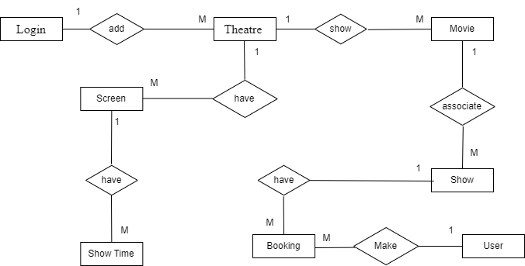
Figure 1 - Entities

Attributes
Here are the attributes for each entity.

    - Theatre
- Attributes:
  - T_ID (Primary Key)
  - Name
  - Place
  - Address
  - Pin
  - State
- Booking
- Attributes:
  - Book_ID (Primary Key)
  - Amount
  - No_Seats
  - Ticket_Date
  - Date
  - Status
  - User_ID (Foreign Key referencing User.User_ID)
  - S_ID (Foreign Key referencing Show.S_ID)
- Login
- Attributes:
  - ID (Primary Key)
  - Username
  - Password
  - User_Type
  - UserID

- Screen
- Attributes:
  - Screen_ID (Primary Key)
  - Screen_Name
  - Seats
  - Charge
  - T_ID (Foreign Key referencing Theatre.T_ID)
- Show
- Attributes:
  - S_ID (Primary Key)
  - Start_Date
  - Status (Availability)
  - R_Status
  - M_ID (Foreign Key referencing Movie.Movie_ID)
  - T_ID (Foreign Key referencing Theatre.T_ID)
- Movie
- Attributes:
  - Movie_ID (Primary Key)
  - Movie_Name
  - Release_Date
  - Status
  - Description
  - Image
  - Video_URL
  - Cast

- ShowTime
- Attributes:
  - ST_ID (Primary Key)
  - Start_Time
  - Name
  - Screen_ID (Foreign Key referencing Screen.Screen_ID)
  - S_ID (Foreign Key referencing Show.S_ID)

- User
- Attributes:
  - User_ID (Primary Key)
  - Name
  - Phone_No
  - Age
  - Email

Entity Relationships
- Theatre and Screen (1:M)
  - A Theatre can have multiple Screens.
  - Key Mapping: tbl_theatre.t_id – tbl_screens.t_id.
- Theatre and Movie (1:M)
  - A Theatre can show multiple Movies.
  - Key Mapping: tbl_theatre.t_id – tbl_movie.t_id.
- Screen and Show Time (1:M)
  - One Screen can have multiple Show Times.
  - Key Mapping: tbl_screen.screen_id – tbl_show_time.screen_id.
- Show Time and Show (1:M)
  - A Show Time can have multiple Shows.
  - Key Mapping: tbl_show_time,st_id – tbl_show,st_id.
- Movie and Shows (1:M)
  - A Movie can be associated with multiple Shows.
  - Key Mapping: tbl_movie.movie_id – tbl_shows.movie_id.
- Show and Booking (1:M)
  - A Show can have multiple Bookings.
  - Key Mapping: tbl_shows.s_id – tbl_bookings.show_id.
- User and Booking (1:M)
  - A User can make multiple Bookings.
  - Key Mapping: tbl_registration.user_id – tbl_bookings.user_id.
- Login and Theatre (1:M)
- Admin can add multiple theatres.
- Key Mapping: tbl_login.user_id – tbl_theatre.t_id

- Booking and Screens (1:M)
- Bookings are connected to Screens through Show and Show Time
- Key Mapping: tbl_bookings.screen_id – tbl_screens.screen_id
- Show and Screen (1:M)
- Bookings are linked to Theatres via Shows, Show Time, and Screens.
- Key Mapping: tbl_bookings. t_id – tbl_theatre.t_id
- Show and Theatre (1:M)
- Shows are linked to Theatres via Screens.
- Key Mapping: tbl_shows. theatre_id – tbl_theatre.theatre_id.

ER Diagram
Entities & Relationships:
  - Theatre ↔ Screen (1:M)
  - Theatre ↔ Movie (1:M)
  - Screen ↔ Show Time (1:M)
  - Show Time ↔ Show (1:M)
  - Movie ↔ Show (1:M)
  - Show ↔ Booking (1:M)
  - User ↔ Booking (1:M)
  - Login ↔ Theatre (1:M)
  - Booking ↔ Screens (1:M)
  - Show ↔ Screen (1:M)
  - Show ↔ Theatre (1:M)
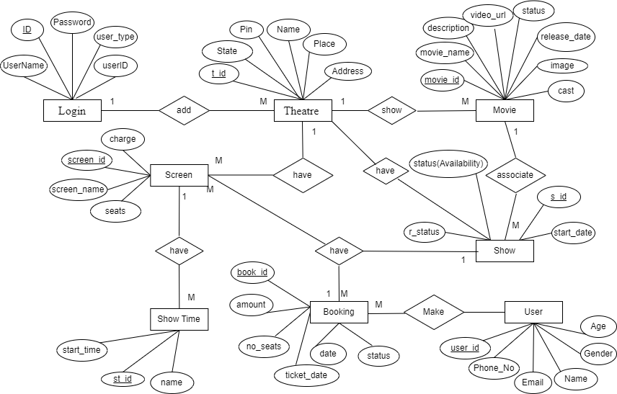
Figure 2 - ER Diagram

UML Diagram
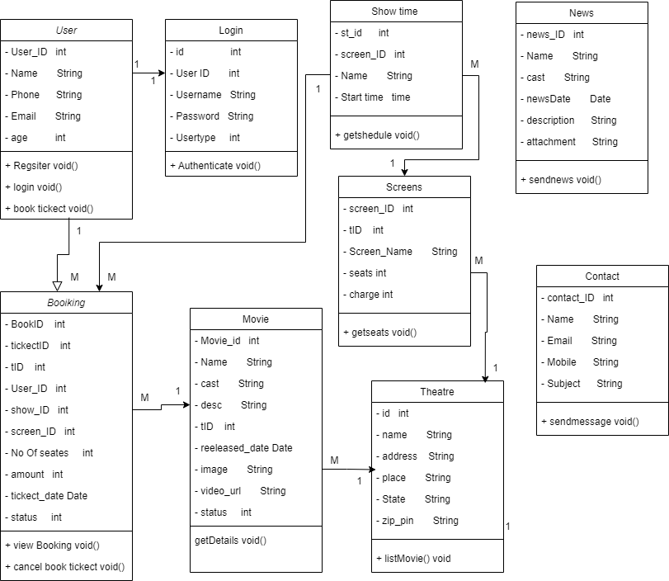
Figure 3 - Class Diagram
Above Figure 3 have two types of relationships. There are one to many relationships (1:M) and many to one relationships (M:1).
- User – Login (1:1)
A user has one Login credential and Login Entry belongs to one User.

- User – Booking (1:M)
Connect User_ID in User to User_ID in Booking.
User can book Multiple tickets and A booking is associated with one user

- Theatre – Screens (1:M)
Connect ID in Theatre to tID in Screens
A Theatre has multiple Screens and A Screen belongs to one Theatre.
- Theatre – Movie (1:M)
Connect tID in Theatre to tID in Movie.
A Theatre can show multiple movies, and A Movie is available in one Theatre.

- Screens – Show Time(1:M)
Connect screen_ID in Screens to screen_ID in Show Times.
A Screen can have multiple showtimes and A Show Time is assigned to one screen.

- Contact (Independent Table)
The Contact table is separate, where users can send messages.
The news_ID is unrelated to other entities.

- News (Independent Table)
The News table is separate, where admin can add New Upcoming News.
The news_ID is unrelated to other entities.

- Booking - Movie (M:1)
Multiple Bookings can be made for the same Movie and A Movie is linked to many bookings.
Connect tID in Booking to tID in Movie.

- Show Time - Booking (1:M)
A Show Time can have multiple Bookings and A Booking is linked to one Show Times.
Connect show_ID in Show Time to show_ID in Booking.

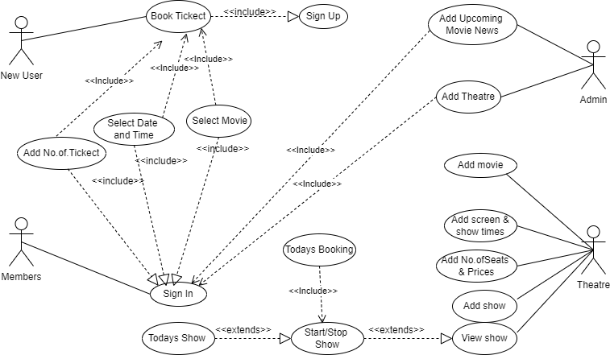
Figure 4 - Use Case Diagram
Actors: Newcomers, Members, Admin, Theatre
Here the above Use case diagram displays about system uses respective actions. The system users are Newcomers, Members Admin and Theatres. The relationships between use cases are shown with <<include>> and <<extend>>. New users must sign up before booking tickets. Admin can add only theatres and upcoming movie news. Members can view movies, Upcoming movie news and movie trailers. But members must log in to the account and select movie and select time then can select date and number of seats before booking tickets. Theatre can add any number of movies and can add screens in theatre have and number of seats and their prices. After that Theatre can create shows using movie screens and show time with start date. The View Show can start, stop and end movies using web applications, and then can check day-to-day shows and after start show can check day-to-day booking.

Business Rules

Here is a list of critical business rules that the database must enforce based on the provided model:
- User and Login:
  - Users must have a unique login ID and username.
  - Three users are admin, theatre, and customer admin is already added
  - A login must be associated with exactly one user.
- Theatre:
  - Each theatre must have a unique identifier (T_ID).
  - A theatre can have multiple screens, but each screen must belong to only one theatre.
- Screen:
  - Each screen must have a unique identifier (Screen_ID).
  - A screen must be associated with a single theatre.
  - Each screen must define the number of available seats and charge per seat.
- Movie:
  - Each movie must have a unique identifier (Movie_ID).
  - A movie can be shown in multiple theatres and at multiple times, but each show must link to one movie.
  - Movies must include key details like name, release date, cast, and video URL.
- Show:
  - A show must have a unique identifier (S_ID).
  - A show must belong to one theatre and be associated with one movie.
  - A show must indicate its availability status.
- ShowTime:
  - A showtime must have a unique identifier (ST_ID).
  - Each showtime must belong to a specific screen.
  - A screen can have multiple showtimes but only one showtime per time slot.

- Booking:
  - Each booking must have a unique identifier (Book_ID).
  - A booking must be linked to one user and one show.
  - The number of seats booked must not exceed the available seats for the selected showtime.
  - Each booking must include details like the amount paid, number of seats booked, ticket date, and status.
- User:
  - A user must have a unique identifier (User_ID) and valid contact details (email and phone number).
  - Users can book multiple tickets with any number of seats, but each bookings must be linked to one user.
- General Rules:
  - The database must enforce referential integrity by ensuring that all foreign key relationships are valid.
  - No duplicate entries are allowed for primary keys in any table.

Logical Design

Data Model
    - tbl_bookings
- book_id: (PK) Unique ID for each booking.
- ticket_id: Unique ticket identifier.
- t_id: (FK) Theatre ID, links to tbl_theatre.
- user_id: (FK) User ID, links to tbl_registration.
- show_id: (FK) Show ID, links to tbl_shows.
- screen_id: (FK) Screen ID, links to tbl_screens.
- no_seats: Number of seats booked.
- amount: Total amount for the booking.
- ticket_date: Date when the ticket is issued.
- date: Date of the show.
- status: Status of the booking (active or cancelled).
- tbl_contact
- contact_id: (PK) Unique ID for each contact.
- name: Name of the person contacting.
- email: Contact email address.
- mobile: Contact phone number.
- subject: Subject of the inquiry or feedback.
- tbl_news
- news_id : (PK) Unique ID for each contact
- name: Name of the movie
- cast: List of cast members.
- news_date: released date
- description: Description of the movie
- attachment: Upcoming movie image

- tbl_login
- id: (PK) Unique login ID.
- user_id: User ID Unique
- username: Unique Username, typically the email address.
- password: User's password (hashed).
- user_type: Type of user (Admin: 0, Theatre: 1, Customer: 2).
- tbl_movie
- movie_id: (PK) Unique ID for each movie.
- t_id: (FK) Theatre ID, links to tbl_theatre.
- movie_name: Name of the movie.
- cast: List of cast members.
- des: Description of the movie.
- release_date: Movie's release date.
- image: Image URL for the movie poster.
- video_url: URL for the movie's trailer or video.
- status: Movie's status (active or inactive).
- tbl_registration
- user_id: (PK) Unique ID for the user.
- name: user name and account create with that name.
- email: user email address and it is used for login.
- phone: user phone number.
- age: user age.
- tbl_screens
- screen_id: (PK) Unique ID for the screen.
- t_id: (FK) Theatre ID, links to tbl_theatre.
- screen_name: Name of the screen.
- seats: Total number of seats in the screen.
- charge: Charge per seat.

- tbl_shows
- s_id: (PK) Unique ID for the show.
- st_id: (FK) Show time ID, links to tbl_show_time.
- t_id: (FK) Theatre ID, links to tbl_theatre.
- movie_id: (FK) Movie ID, links to tbl_movie.
- start_date: Show's start date.
- status: Status of the show (available or not).
- r_status: Reservation status (can indicate if the show is fully booked or open).

- tbl_show_time
- st_id: (PK) Unique ID for shows available times.
- screens_id: (FK) Theaters has Number of screens with film hall,So this ID links with tbl_screen.
- name: Name of the show time (e.g., "Noon", "Second").
- start_time: Time at which the show starts.

- tbl_theatre
- t_id: (PK) Unique and Auto Incremented for the theatre.
- name: Theatre Name.
- address: Theatre Location.
- place: Place (city) where the theatre is located.
- state: State where the theatre is located.
- pin: Postal code (PIN) of the theatre's location.

Relationships:
    - tbl_bookings:
  - Many-to-One relationship with tbl_theatre (theatre).
  - Many-to-One relationship with tbl_registration (user).
  - Many-to-One relationship with tbl_shows (show).
  - Many-to-One relationship with tbl_screens (screen).
    - tbl_movie:
  - Many-to-One relationship with tbl_theatre (theatre).
    - tbl_registration:
  - One-to-Many relationship with tbl_bookings (user can have multiple bookings).
    - tbl_screens:
  - Many-to-One relationship with tbl_theatre (theatre).
    - tbl_shows:
  - Many-to-One relationship with tbl_theatre (theatre).
  - Many-to-One relationship with tbl_movie (movie).
  - Many-to-One relationship with tbl_show_time (show time).
    - tbl_show_time:
  - Many-to-One relationship with tbl_screens (screen).
    - tbl_theatre:
  - One-to-Many relationships with tbl_movie (theatre can have any No. of movies).
  - One-to-Many relationships with tbl_screens (theatre can have any No. of screen).
  - One-to-Many relationship with tbl_shows (theatre can host multiple shows).
  - One-to-Many relationship with tbl_bookings (theatre can have many bookings).
    - tbl_contact, tbl_news tbl_login:
  - No direct relationships with other tables.

Tables and Columns
- User (tbl_registration)
Attributes: user_id, name, email, phone, age
- Theatre (tbl_theatre)
Attributes: t_id, name, address, place, state, pin
- Movie (tbl_movie)
Attributes: movie_id, movie_name, , release_date, cast, des, release_date, image, video_url, status, t_id
- Screens (tbl_screens)
Attributes: screen_id, t_id, screen_name, seats, charge
- Show Times (tbl_show_time)
Attributes: st_id, screenid, name, start_time.
- Login (tbl_login)
Attributes: id, user_id, password, user name usertype.
- Show (tbl_shows)
Attributes: s_id, st_id, t_id, movie_id, start_date, status, r_status
- Booking (tbl_bookings)
Attributes: book_id, ticket_id, t_id, user_id, show_id, screen_id, no_seats, amount, ticket_date, date, status
- Contact (tbl_contact)
Attributes: contact_id, name, email, mobile, subject
- Upcoming Movie News (tbl_news)

Attributs: news_id, name, cast, news_date, description, attachment

Normalization Process

- 1NF - First Normal Form
- Criteria – Remove repeating groups. Ensure that each column contains atomic values and that each row is unique.
- Evaluation – All tables have unique primary keys, and all are AUTO_INCREMENT Columns

- 2NF - Second Normal Form
- Criteria: Meet 1NF and remove partial dependencies (a non-primary attribute does not depend on part of a composite primary key).
- Evaluation – Tables like tbl_bookings, tbl_movies, and tbl_registration have simple primary keys. The schema has no composite keys, so partial dependencies are not an issue.

- 3NF - Third Normal Form
- Criteria – Meet 2NF and eliminate transitive dependencies (a nonprime attribute does not depend on another nonprime attribute).
- Evaluation – Tables are well-designed with logical attributes grouped such as tbl_movie holds movie-specific details). Here all the non-key attributes depend directly on the primary key.
- For examples:
- In the tbl_bookings, attributes like no_seats and amount depend directly on book_id
- In the tbl_movie, attributes like movie_name, cast, and release_date depend on movie_id.

Relational Schema
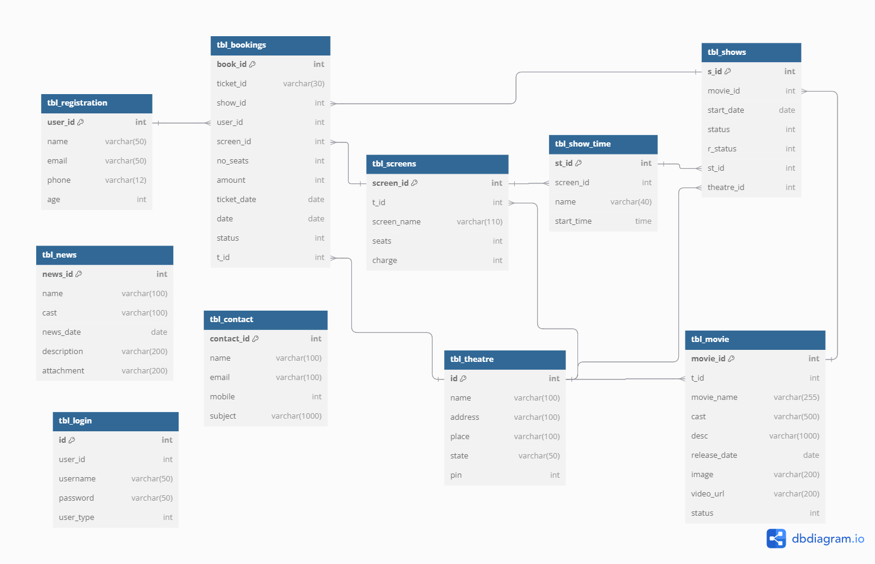
Figure 5 - Class Diagram
https://dbdocs.io/MovieDB?view=ClassDiagram
The provided class diagram represents a movie theater ticket booking system with multiple interconnected tables. The tbl_registration table stores user information such as name, email, phone, age, and tbl_login handle user authentication with fields for email or username, password, and user type. tbl_bookings records ticket bookings, linking users, and maintaining shows, screens, and theater seat numbers, ticket dates, and payment amounts. The tbl_movie table manages movie details including cast, description, release date, and multimedia links. The tbl_theatre table stores theater-related information such as name, address, and location. The tbl_screens table associates screens with theaters, providing details about seating capacity and ticket prices. Showtimes are handled through tbl_shows and tbl_show_time, defining movie screenings and their times. Additionally, the tbl_news table maintains updates on movies and related information, while tbl_contact manages user queries.

Physical Design

Table Definitions
    - Table Name – tbl_booking
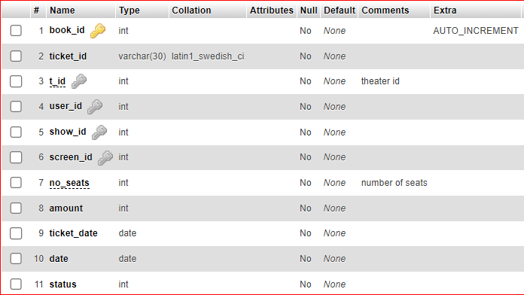
Figure 6 - Booking Table
    - Table Name – tbl_contact
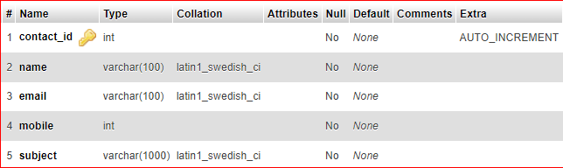
Figure 7 - Contact Table
    - Table Name – tbl_login
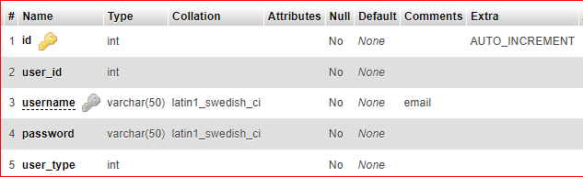
Figure 8 - Login Table

- Table Name – tbl_movie
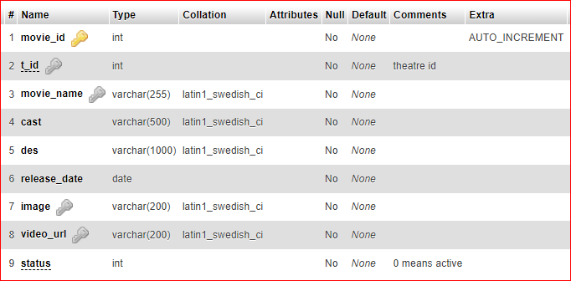
Figure 9 – Movie Table
- Table Name – tbl_theatre
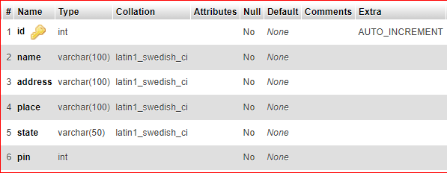
Figure 10 – Theatre Table
- Table Name – tbl_news
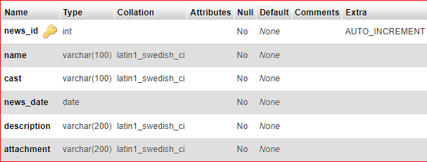
Figure 11 – News Table

- Table Name – tbl_registration
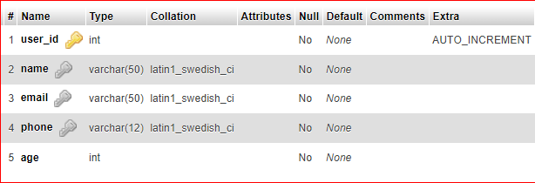
Figure 12 - Register Table
- Table Name – tbl_screens
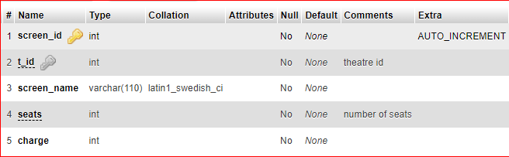
Figure 13 - Screen Table
- Table Name – tbl_shows
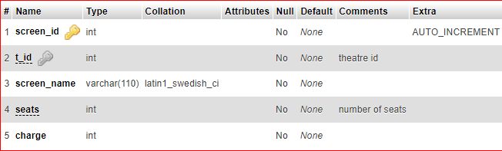
Figure 14 - Show Table
- Table Name – tbl_show_time
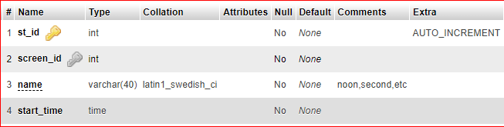
Figure 15 - Show Time Table

Indexing and Optimization
Below table discuss about the selection of primary and foreign keys for indexing.
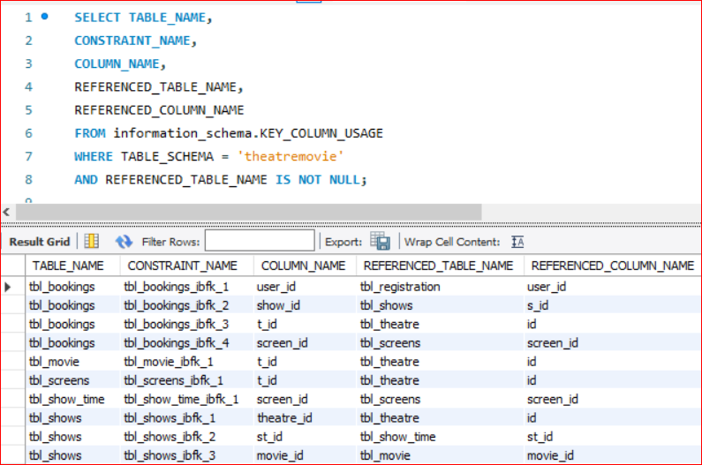
Figure 16 - Indexing and Optimization

Storage Considerations
    - Check total Disk Space for the my "theatremovie" Database system
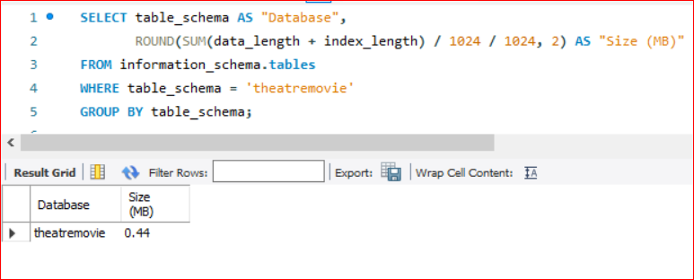
Figure 17 - Disk Space
Total Disk Space is 0.44 MB.
    - Check Disk Space Used by Each Table in Database
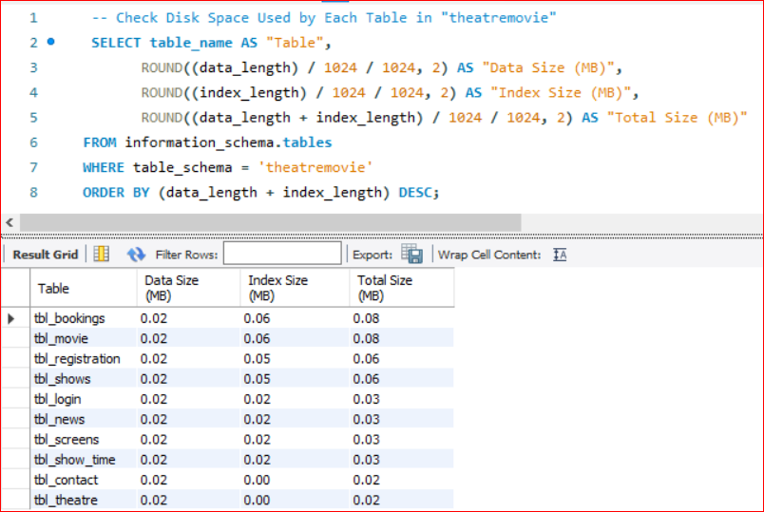
Figure 18 - Tables for disk space
    - Check Storage Engine for Each Table in Database
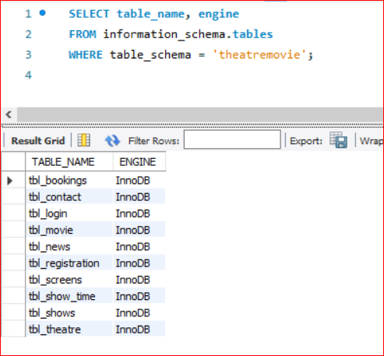
Figure 19 - Check Storage Engine
    - Check Indexes in Tables
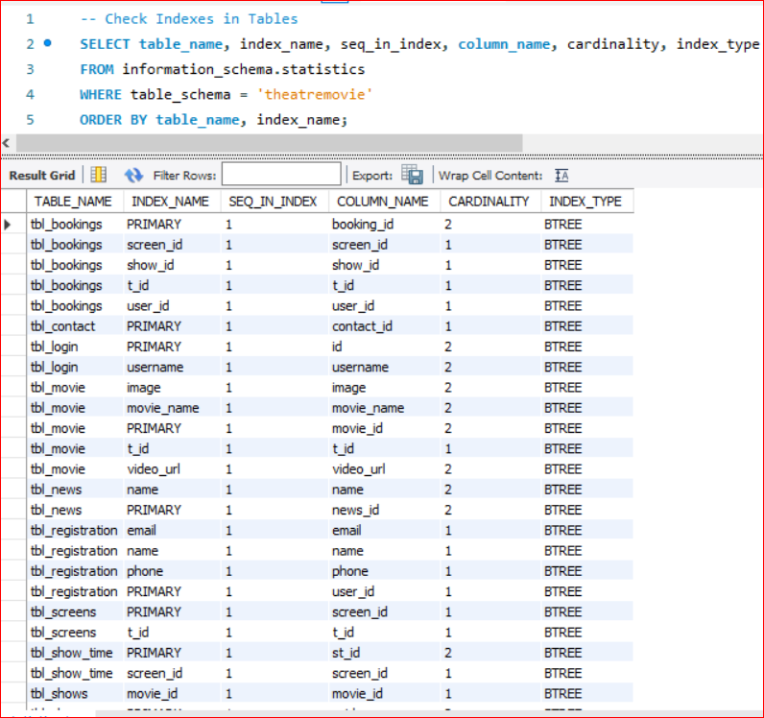
Figure 20 - Table Indexes
    - Check free disk space on MYSQL server
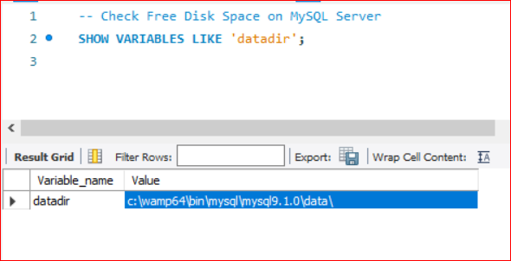
Figure 21 - Free disk Space

Backup in MySQL
Figure 22 - Getting Backup
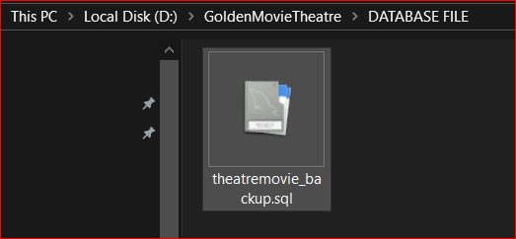
Figure 23Backup File

Transaction Analysis

Transaction Requirements
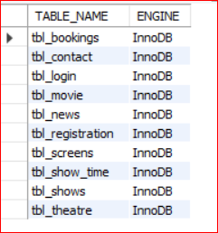
1. Check If Transactions Are Supported
Figure 24 Check Transaction support
Ensure my database tables use InnoDB because MyISAM does NOT support transactions

ACID Properties
- Atomicity
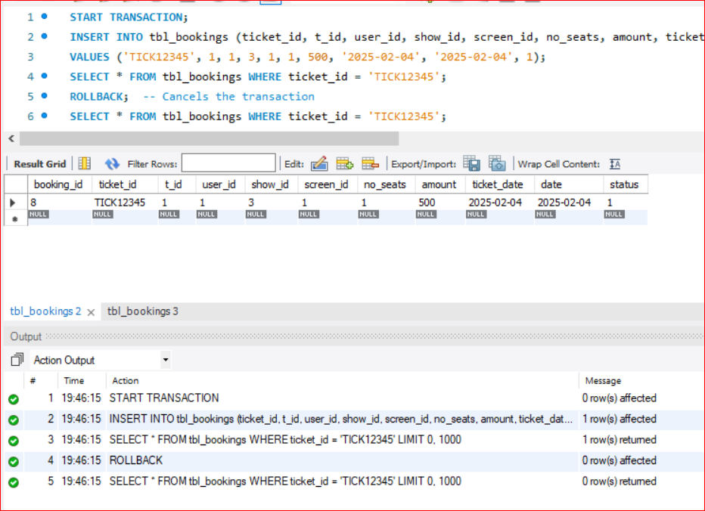
Figure 25 - Atomicity
Here Atomicity works, So the last SELECT should return no results because ROLLBACK undid the insert.

- Consistency
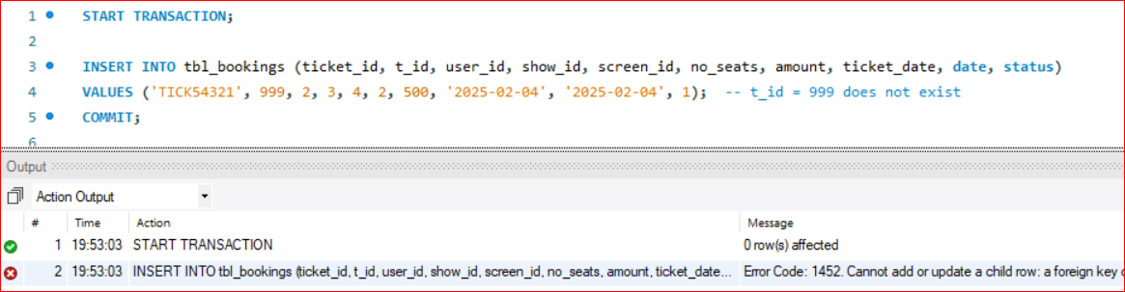
Figure 26 - Consistency
This should fail due to foreign key constraints, which proves consistency.

- Isolation
Session 1: Start a Transaction and without Commit
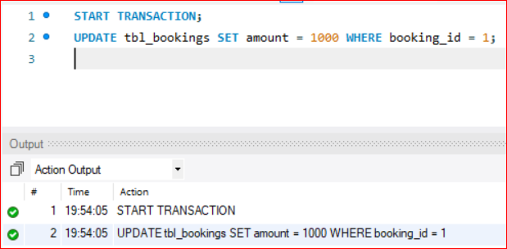
Figure 27 - Isolation 1

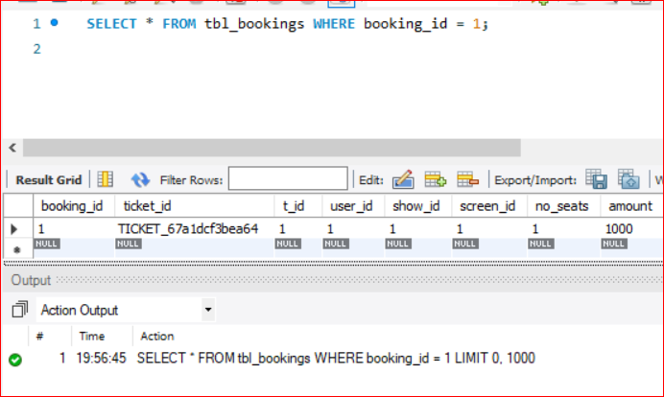
Session 2: Try Reading the Uncommitted Data
Figure 28 - Isolation 2

- Durability
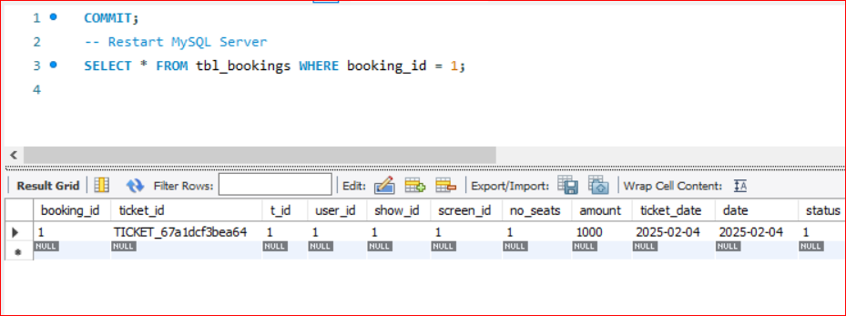
Figure 29 – Durability

Data Dictionary
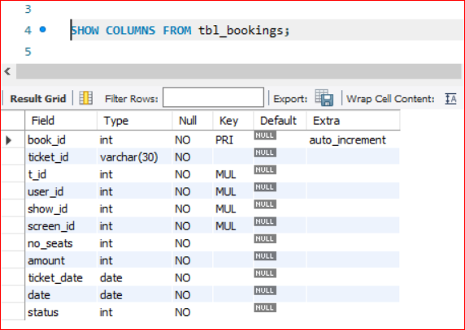
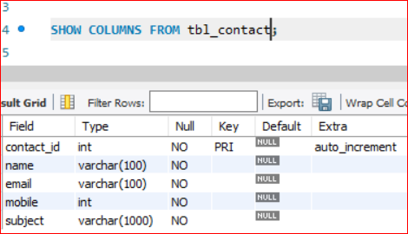
Figure 30 - Columns of Booking Table
Figure 31 - Columns of Booking Table
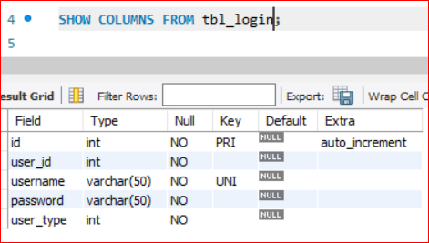
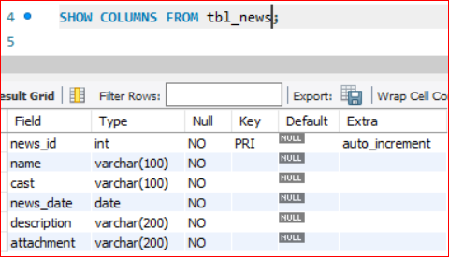
Figure 32 - Columns of Login Table
Figure 33 - Columns of News Table

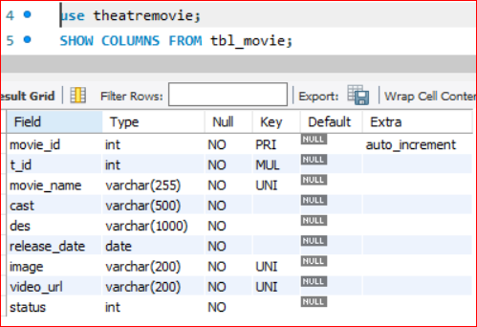
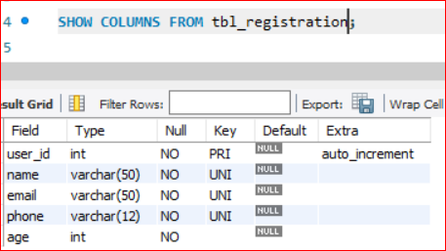
Figure 34 - Columns of Registration Table

Figure 35 - Columns of Movie Table

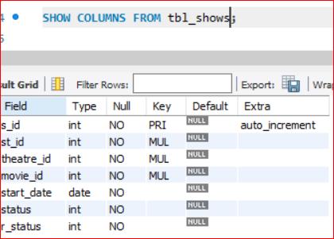
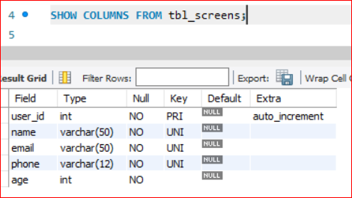
Figure 36 - Columns of Show Table
Figure 37 - Columns of Screen Table

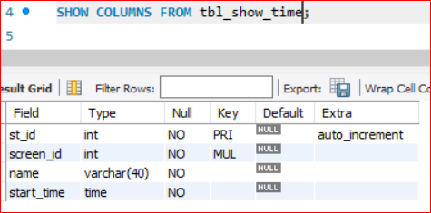
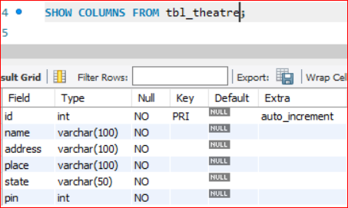
Figure 38 - Columns of Show Time Table
Figure 39 - Column of Theatre Table

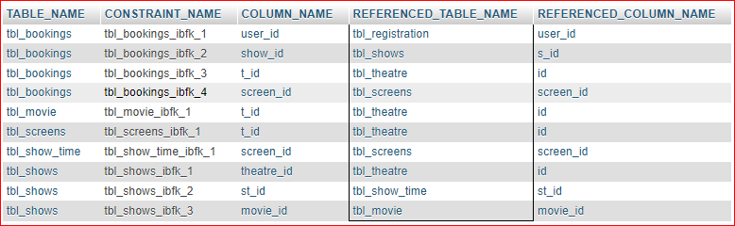
Figure 40 - Foreign Key

Data Dictionary Using phpMyAdmin

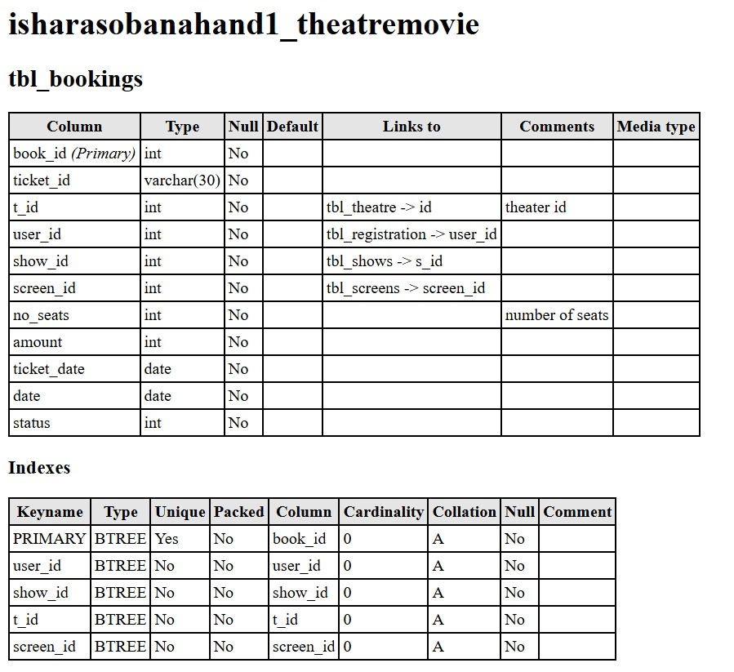
Figure 41 - Data Dictionary tbl_bookings

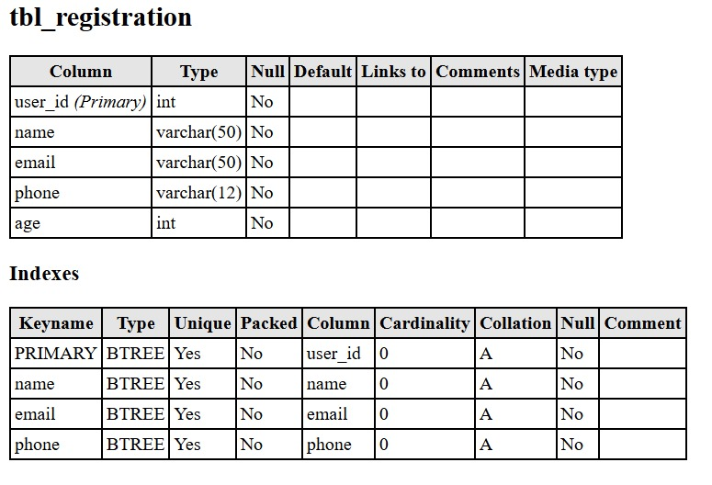
Figure 42 - Data Dictionary tbl_registration
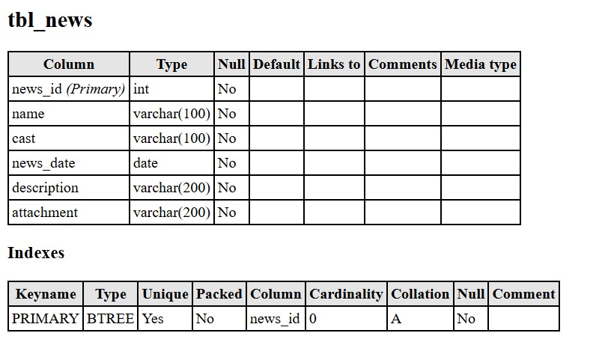
Figure 43 - Data Dictionary tbl_news
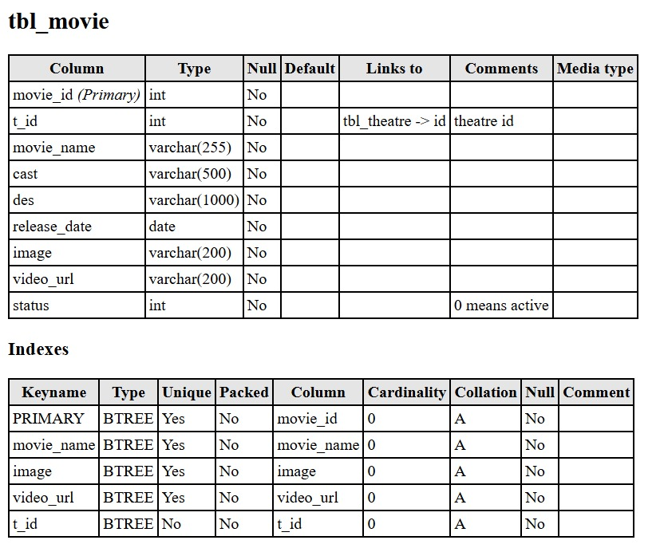
Figure 44 - Data Dictionary tbl_movie
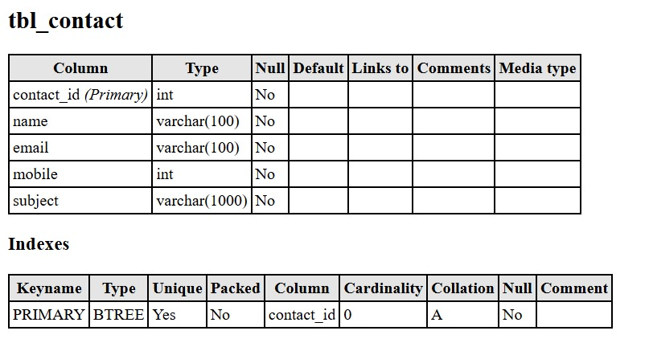
Figure 45 - Data Dictionary tbl_contact

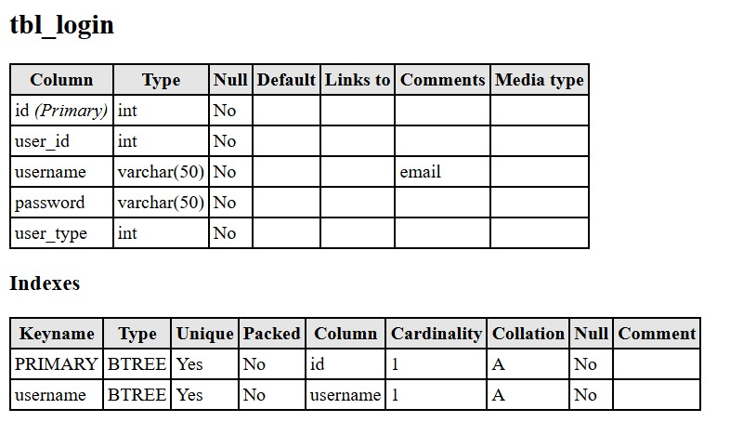
Figure 46 - Data Dictionary tbl_login
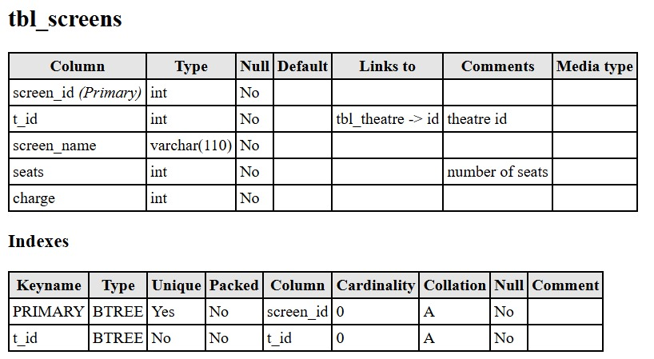
Figure 47 - Data Dictionary tbl_screens
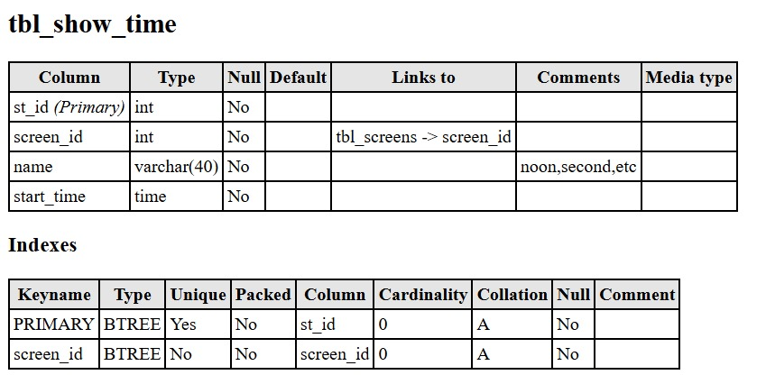
Figure 48 - Data Dictionary tbl_show_time
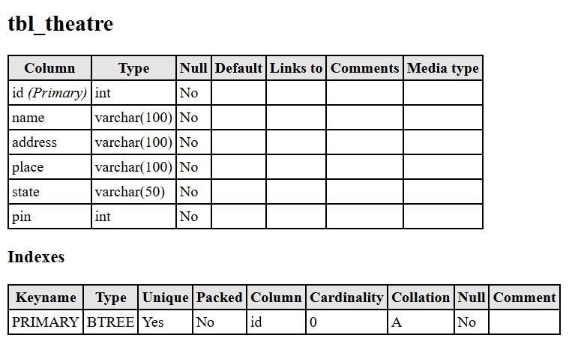
Figure 49 - Data Dictionary tbl_theatre

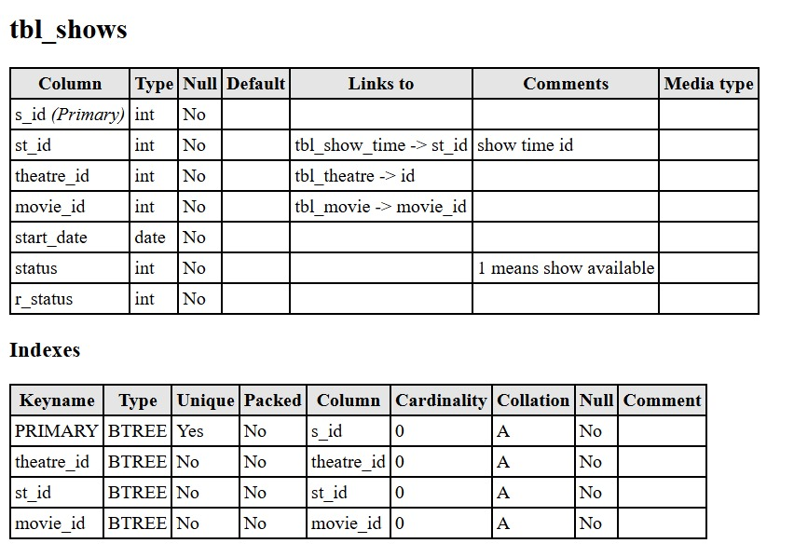
Figure 50 - Data Dictionary tbl_shows

This data dictionary, we got it using my phpMyAdmin data dictionary.

Part 02: Database System Development

Database Implementation and Testing

Implementation
Here is a display about PHP code for CRUD Operations.

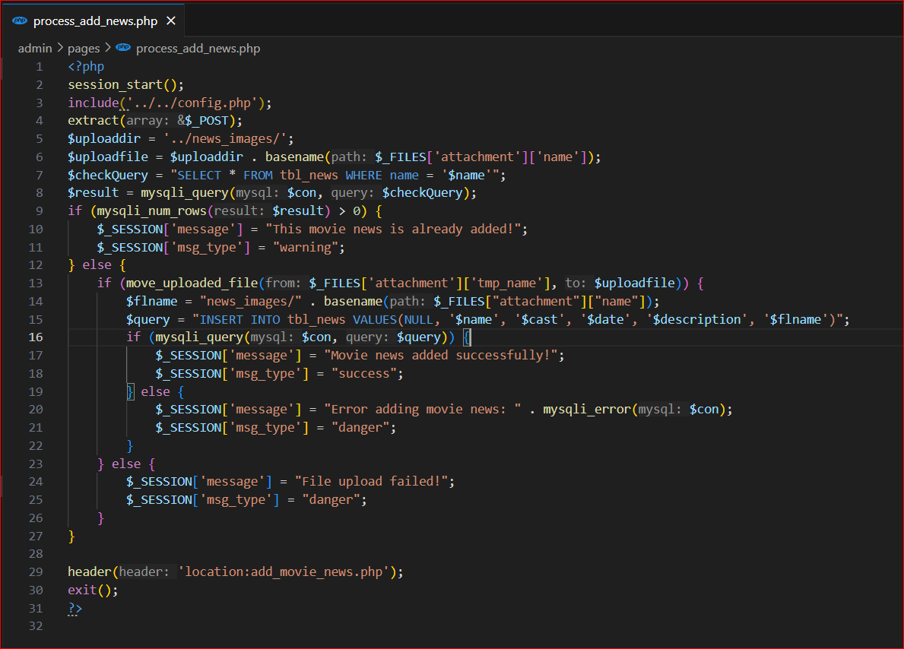
Figure 51 - Insert News
This is a PHP code for a insert upcoming news process in admin part. Above code rule.No.15 has insert command. So, this code used to insert all the data insert to the database.
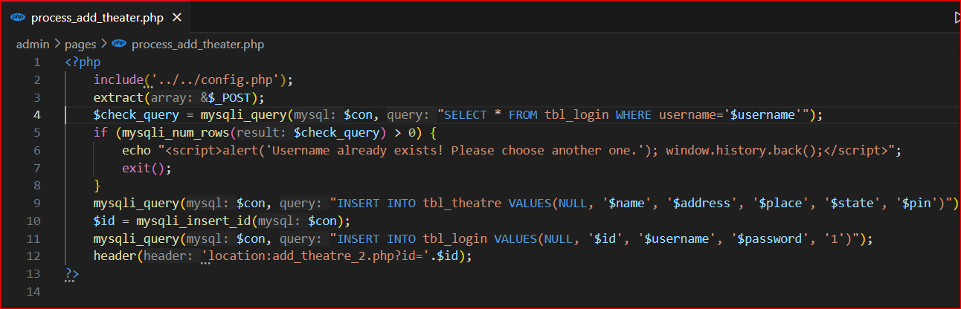
Figure 52 - Insert Theatres
This process_add_theatre.php is used to add theatres. Admin can add any number of theatres. Above image has two INSERT COMMAND. Rule.no.09 has insert theatre details. No.11 is used to that theatre’s username and password add to login page.
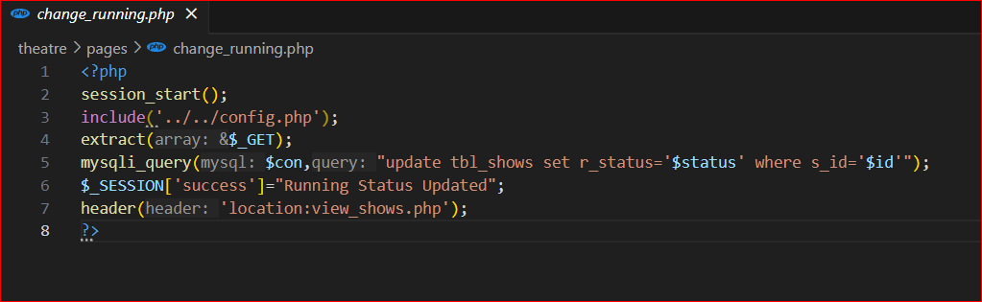
Figure 53 - Update Runing
This is used to view_show.php page button change. That button one time click Start Runing and Stop Running. So this code want to change status like 1 or 0 for check available or not available.

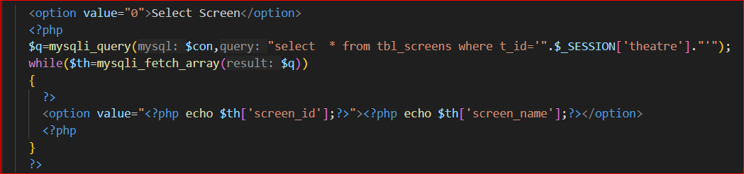
Figure 54 - Read Tickets
This code is used to ticket.php code, read how many tickets sold today for the show.
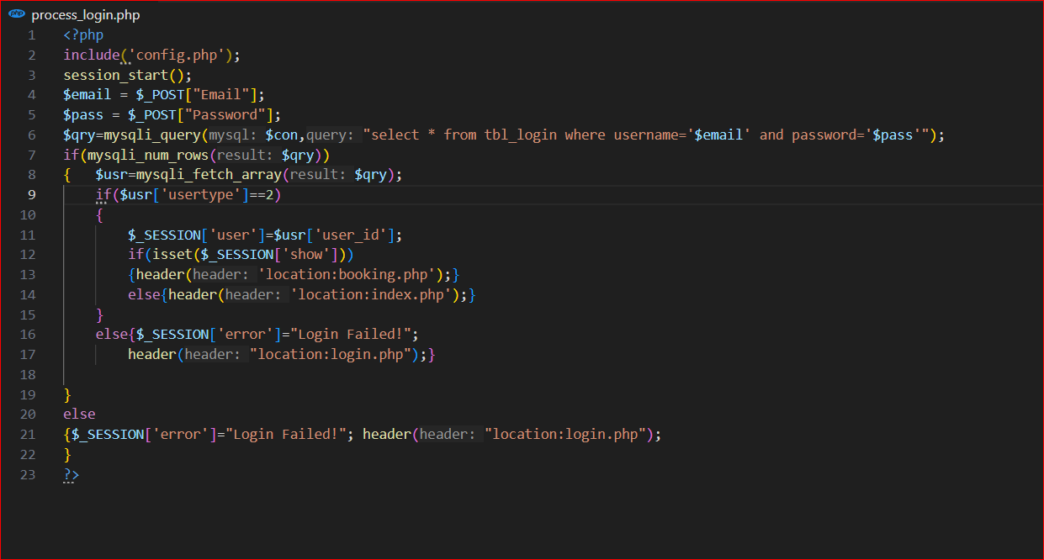
Figure 55 - Check user has account
This is user login page php process. Here SELECT QUERY used to read database table for username is available or not. If username is have then can go to the account. If not have account then have to create account.
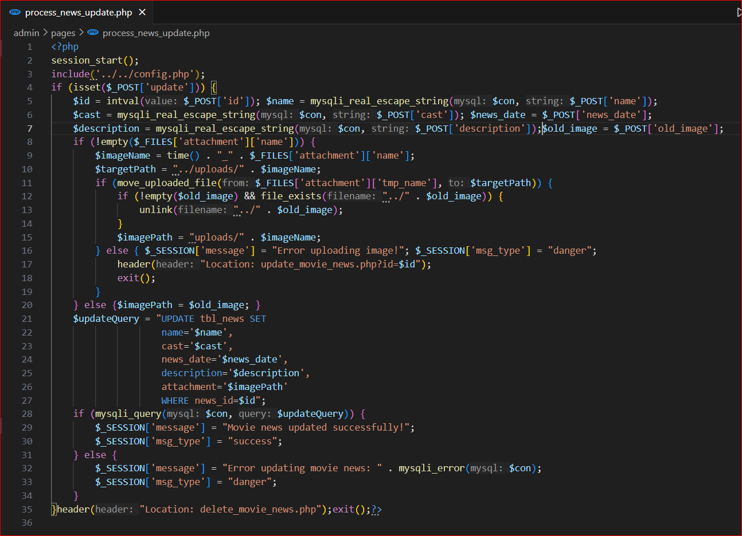
Figure 56 - Update Upcoming News
In this code has UPDATE COMMAND for the Upcoming movie news updated. If some insert value is not correct that time admin can change inserted values using these above image rule.21 query using.
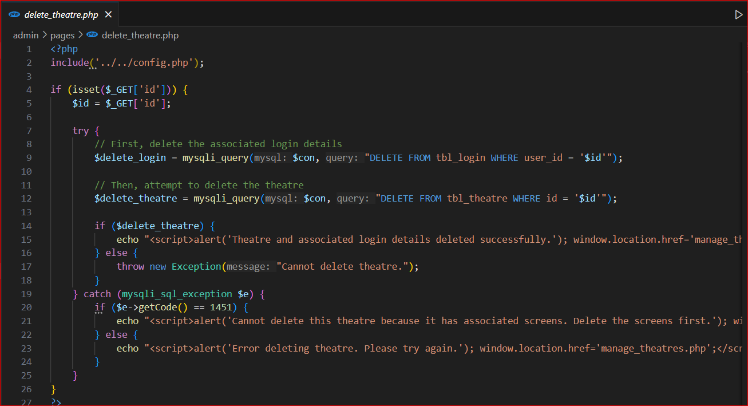
Figure 57 - Delete Command
Here has a delete query for remove theatres. Admin can add theatres and admin can remove them. In this code has two DELETE QUERIES. If admin add theatre that time theatre username password insert to then database so if admin want to remove theatre that time admin have to remove the login table theatre details.

Testing and Validation
We use both bootstrap and html instead of frontend to create the website, and we used PHP for backend, we used WampServer the website through the localhost through the web server.
- Admin Part
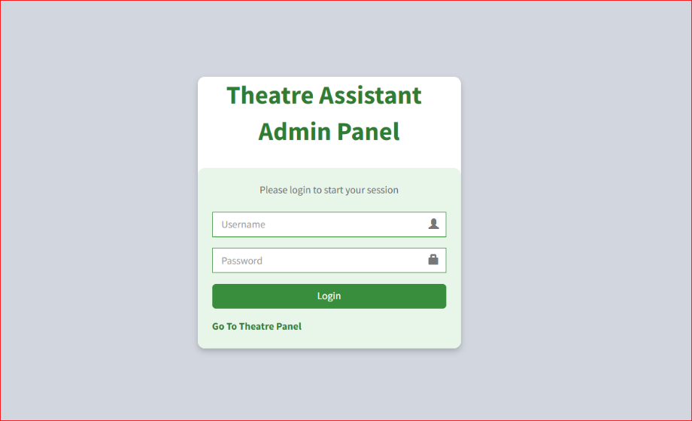
First, Admin will come to this login page. Admin has already inserted the database. So, Admin should login by entering his username and password. If admin enters wrong password or username, an error message will be displayed.
Figure 58 - Admin Login

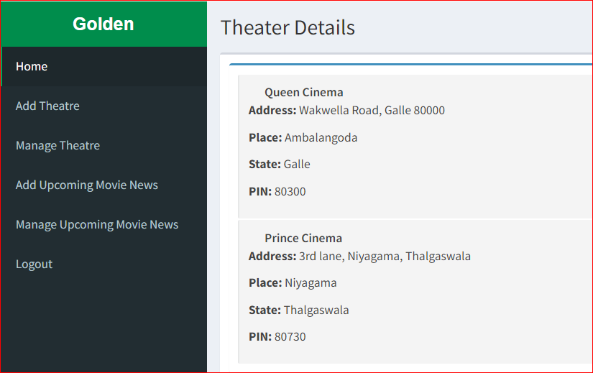
Show this page if the administrator is logged in correctly. This is the index.php page. Here the administrator can see all the theaters added. At this point, there is only one theater, so their details (Theatre Name, Address, Place, State, Pin)are shown.
Figure 59 - Admin Home Page
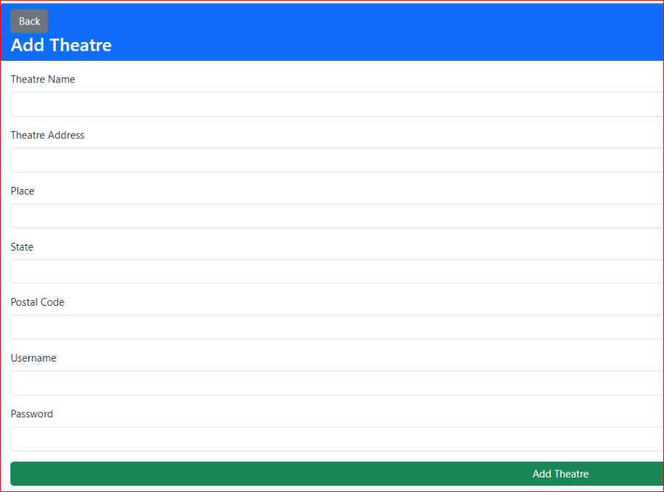
Admin can add theaters. So, this page can add theater details. This form is for html bootstraps used for project templates. Here username is unique and save it to tbl_login table. Here postal code is zip code. And can give any username or password. If click Add Theater button the data save to tbl_theatre table.
Figure 60 - Add Theatre Page

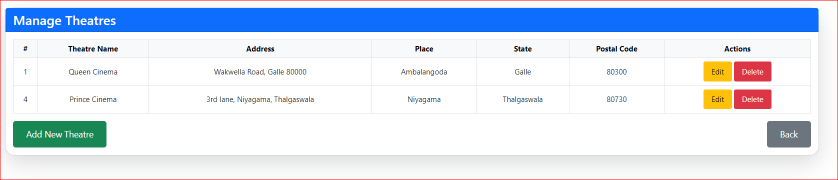
Figure 61 - Manage Theatre Page
Here the admin can update and delete the added theatres details and also can go to the add_theatre.php page to add more theatres. The back button can also be used to go back to index.php. Also, here all theatres details can be seen. If delete button click then display alert with this ‘Are you sure you want to delete this theatre?’ Then click okay button That theatre can delete.

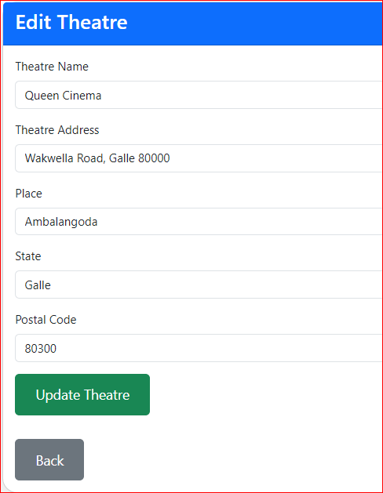
There is an edit button on the image on the Manage Theater page above, Then click it and can come to this page with their data. Then can change the URL , image or anything. Then click the update button and the data will be updated.

Figure 62 - Edit Theatre Page
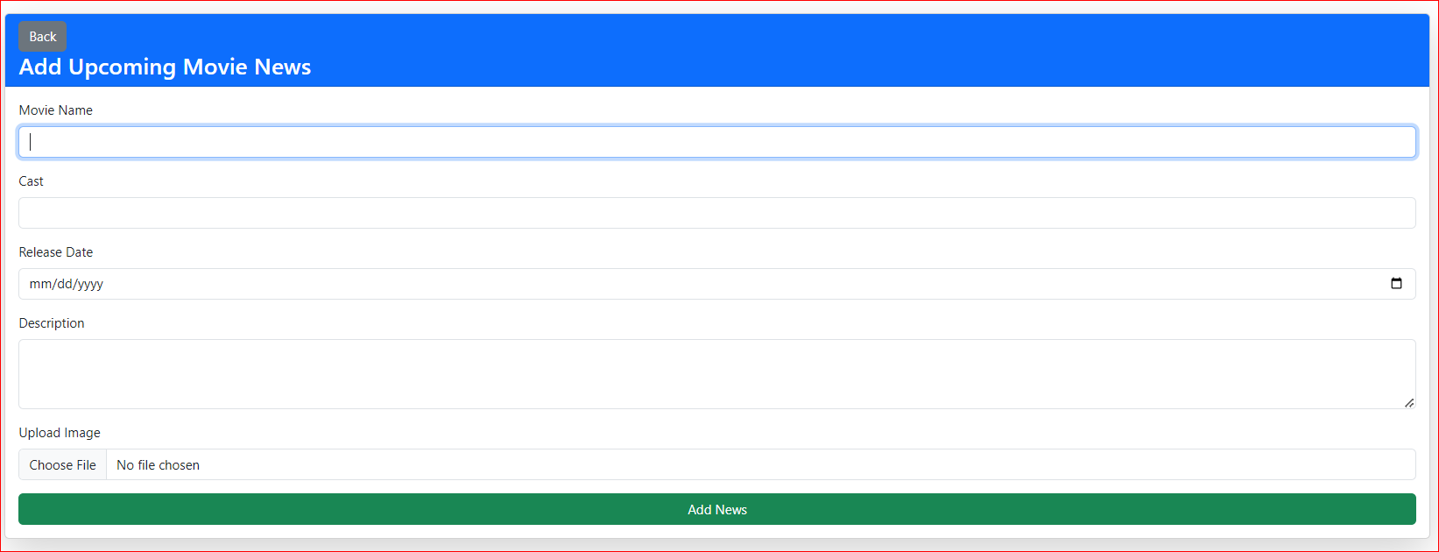
Figure 63 - Add Upcoming Movie News
In the above add_movie_news.php page you can add upcoming movie news with name, image release date description, actors and actresses. There is a select button here, click on that button and you can open files to add image. This has a back button and if you click on it, you will go to the index.php page.

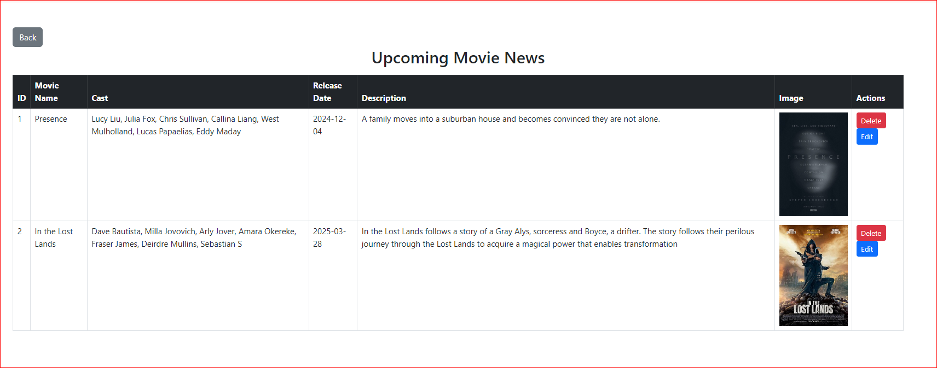
Figure 64 - View News
In this page, we can see all the upcoming movie news that we have entered and all of them have a delete and update button. If we click on the delete button, an alert will appear and then we can delete it. When we click on the update button, we can go to a update form with that data and then we can update it as needed. We can also go back(index.php) using the back button here.
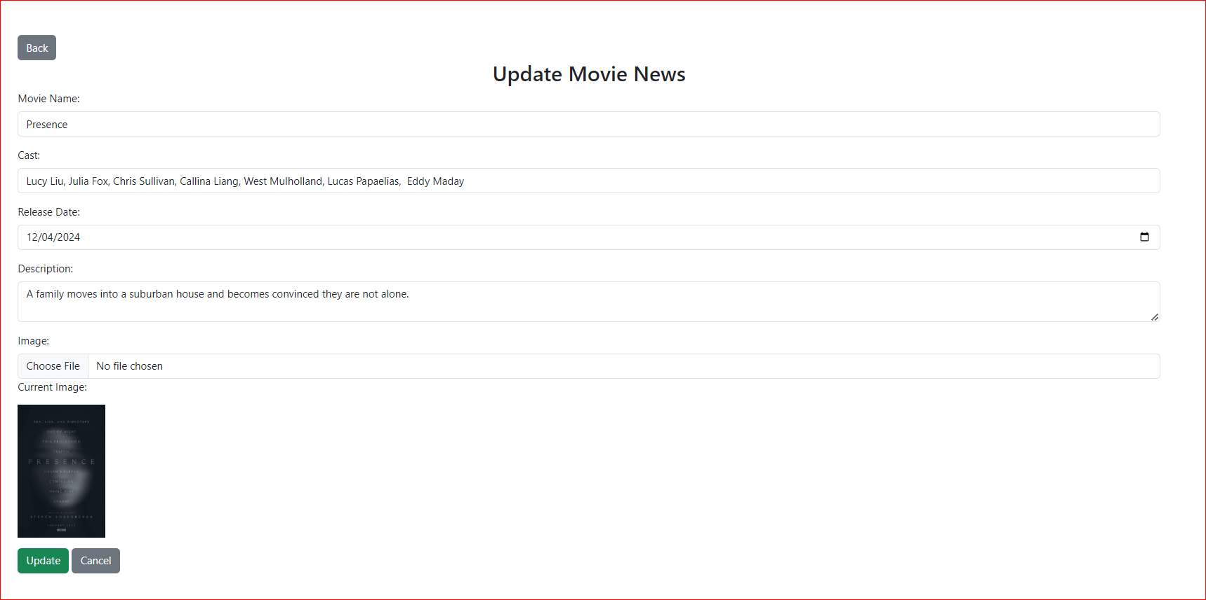
Figure 65 - Update News
The above-mentioned update button here includes the data entered before it is entered here, and after that we can update the data, we want after entering the data we need.

- Theatre Part

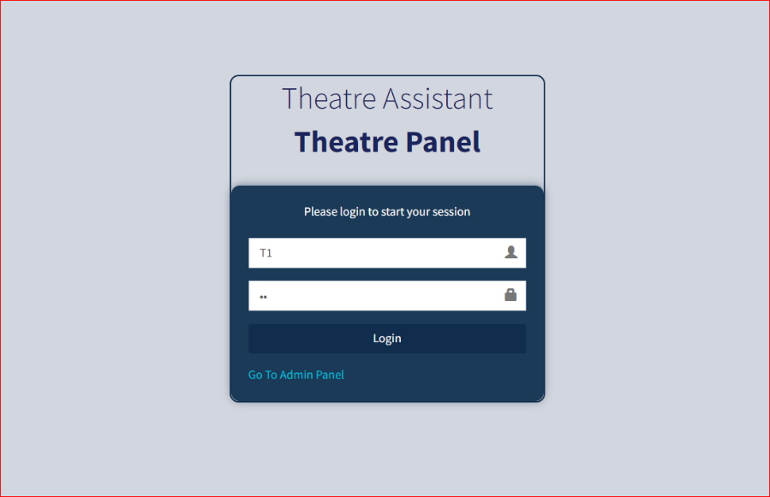
This is a log in to the theatres entered by the admin. Here theatres are required to provide their username and password. If they are unable to provide one, then an error message will be displayed and if the username and password are incorrect, then the same message will be displayed.
Figure 66 - Theatre Login Page

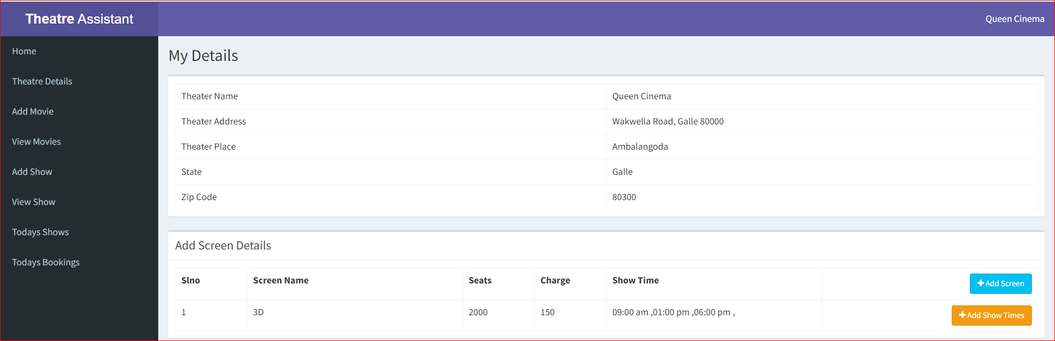
Figure 67 - Account Details
Above is the details of their page entered by the admin, and below it are the buttons needed to add the movie screens and their movie times related to their theater.

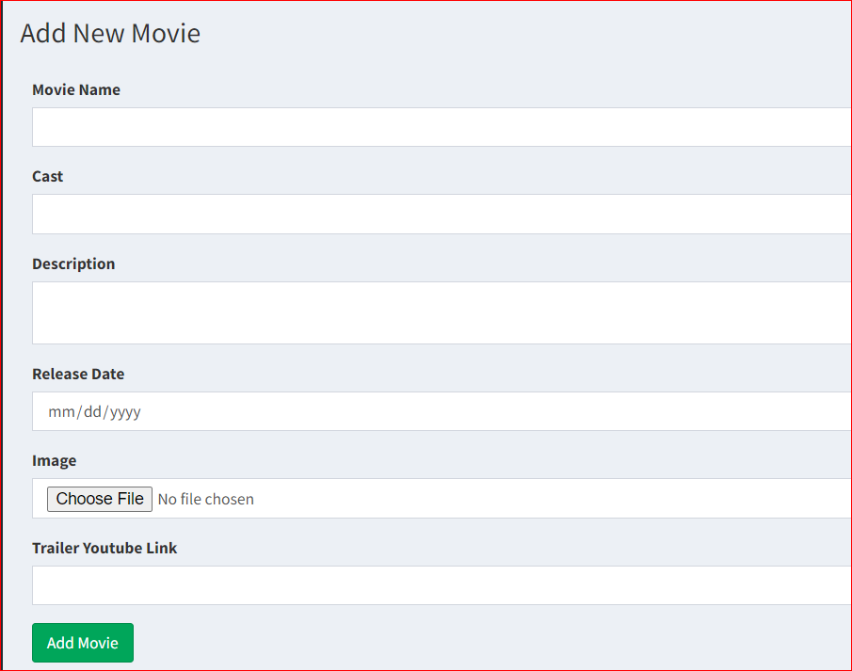
This image shows one of the main pages on our website. Here you can create a list of movies that are currently in their own theaters. They can insert a picture of the movie and any related information.
Figure 68 - Add Movie Page

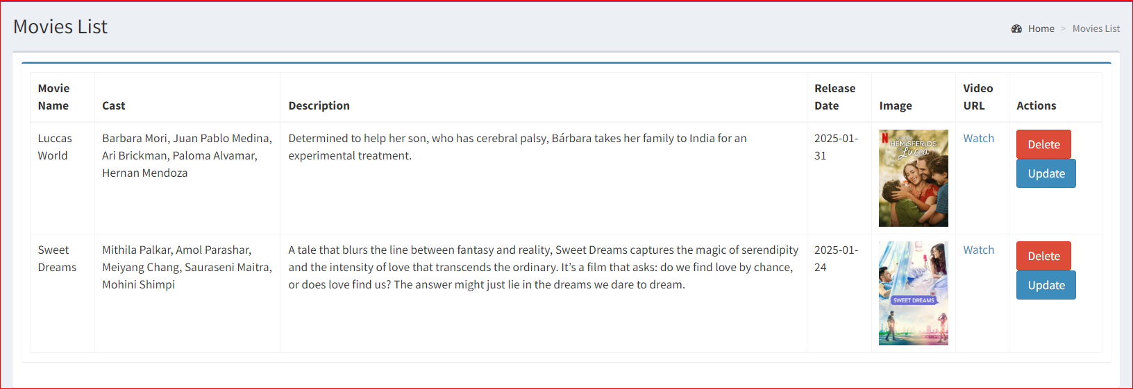
Figure 69 - Manage Movie Page
The image above shows the number of movies available in your theater. Also, there are two buttons for all movies, Update and Delete. When you click the Delete button, you can delete the movie, and when you click the Update button, you can go to the update form.
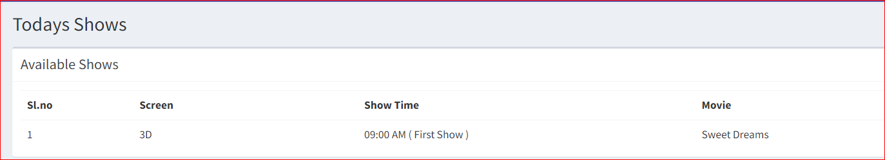
Figure 70 - Today Shows
Daily movie shows are shown here.

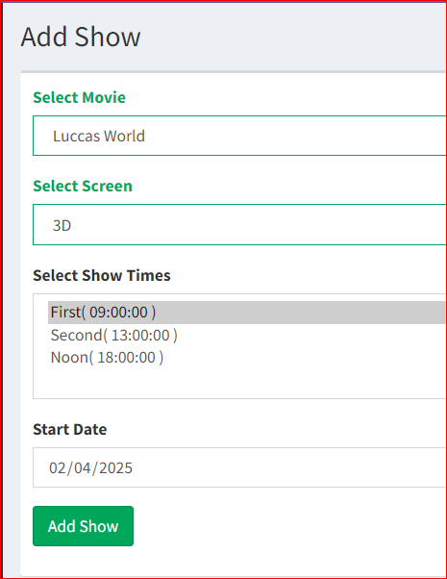
According to the images mentioned above, after selecting the movie, the screen on which the movie is displayed is selected, a time corresponding to that screen is selected, and then the date on which the movie starts is entered, and then a show is added.
Figure 71 - Add shows

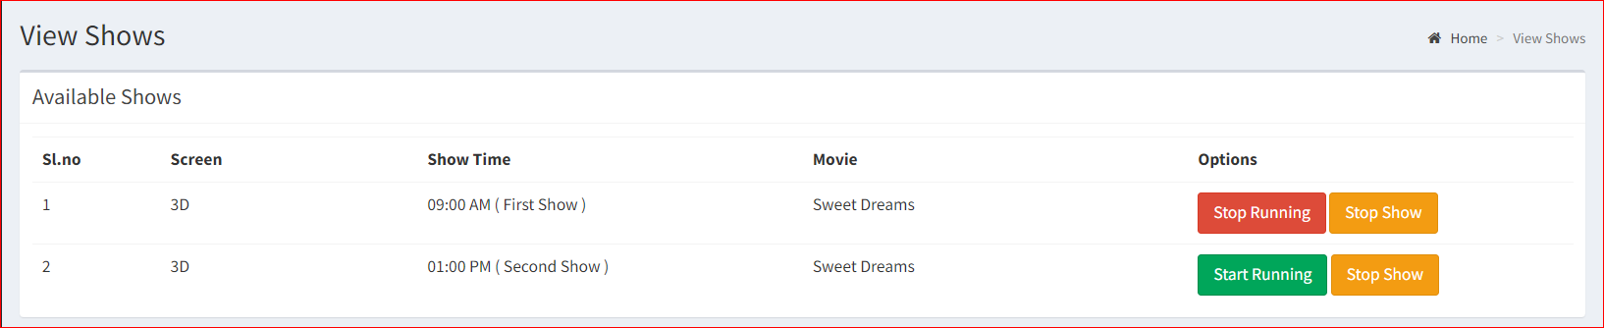
Figure 72 - View show
As per the above image, we can see two buttons. namely stop shows start Running. After clicking on the Start Running button, the button become Stop Running. The show entered in the above image is displayed here and after clicking on the start running button, we can see Today shows and booking.
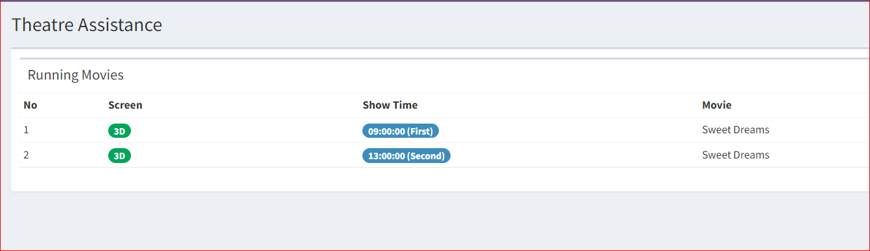
Figure 73 - Running Movies
Current shows are displayed here.

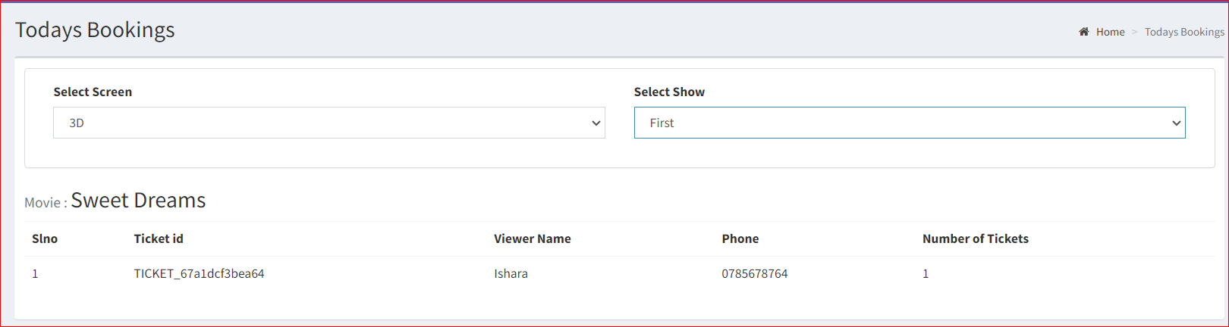
Figure 74 - Available Booking
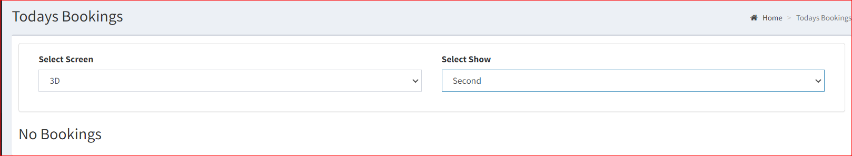
Figure 75 - Non-Available Bookings
The available bookings and unavailable bookings images above show details of seats and tickets booked by everyday customers.

Customer Part
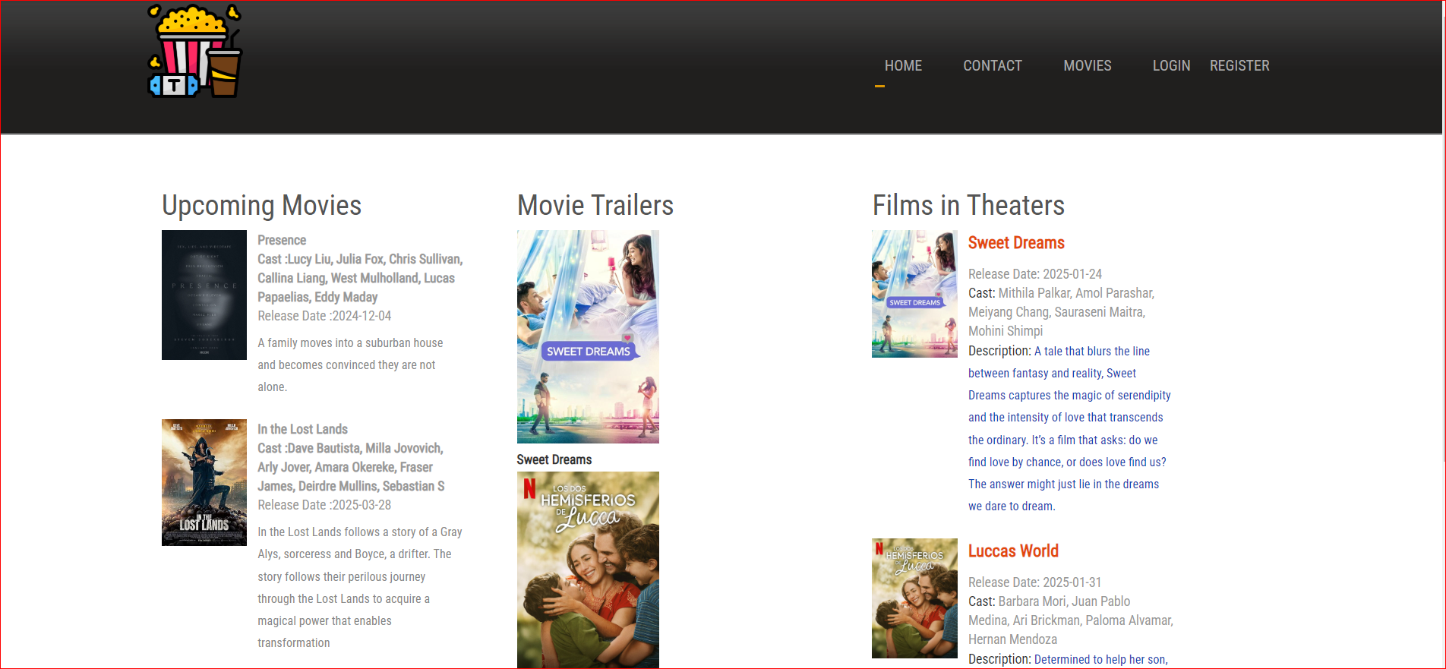
Figure 76 - Home Page
This page is the main page of this website. All customers first come to this page. Then they can register only if they want to ticket book.

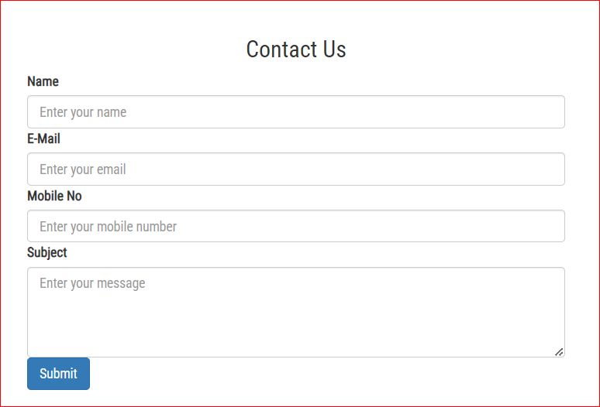
Any person can send a message to the admin through this contact page.
Figure 77 - Contact Us

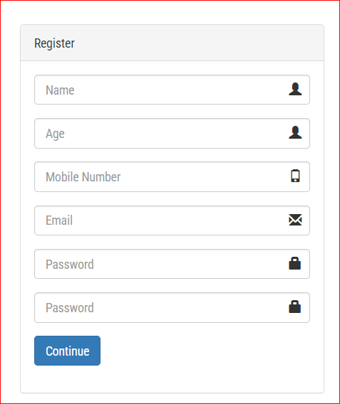
A new visitor to this website can create an account using the registration page.
Figure 78 - Register Form

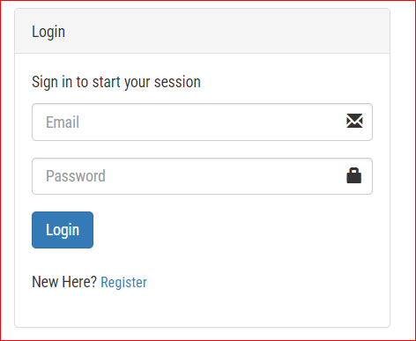
If someone have account they have to give their email and password and then they can log in to their profile.
Figure 79 - Login Form

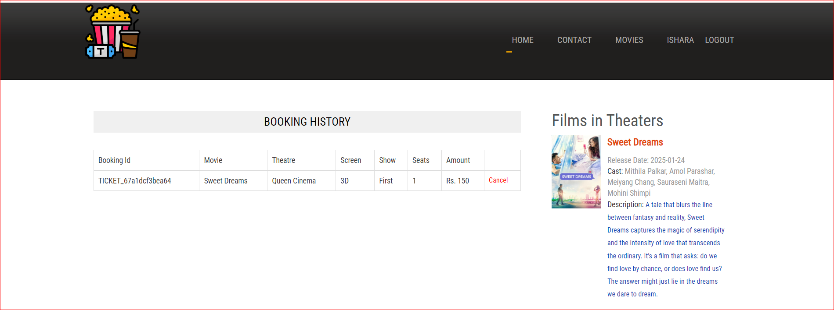
Figure 80 - Profile
After login Correctly, users can go to their profile and check their bookings
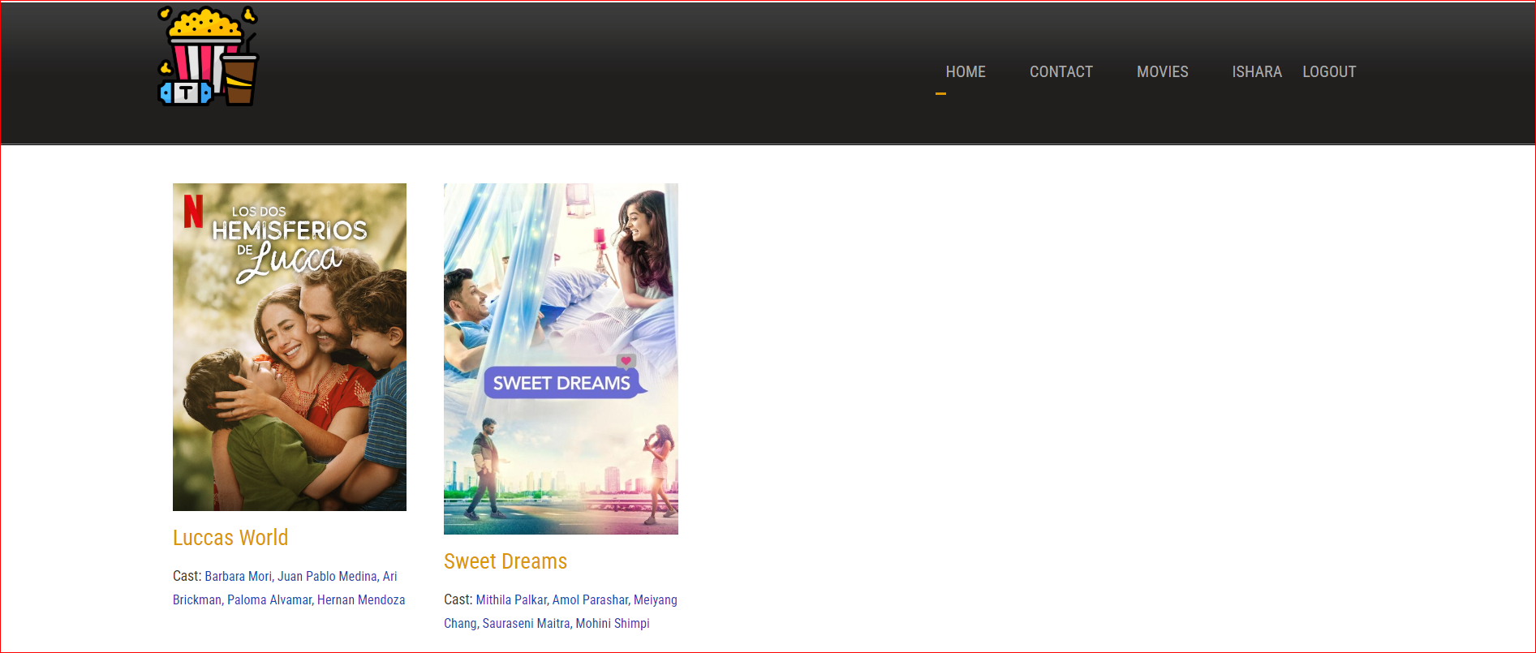
Figure 81 - Move List
This page using users can check all movies.

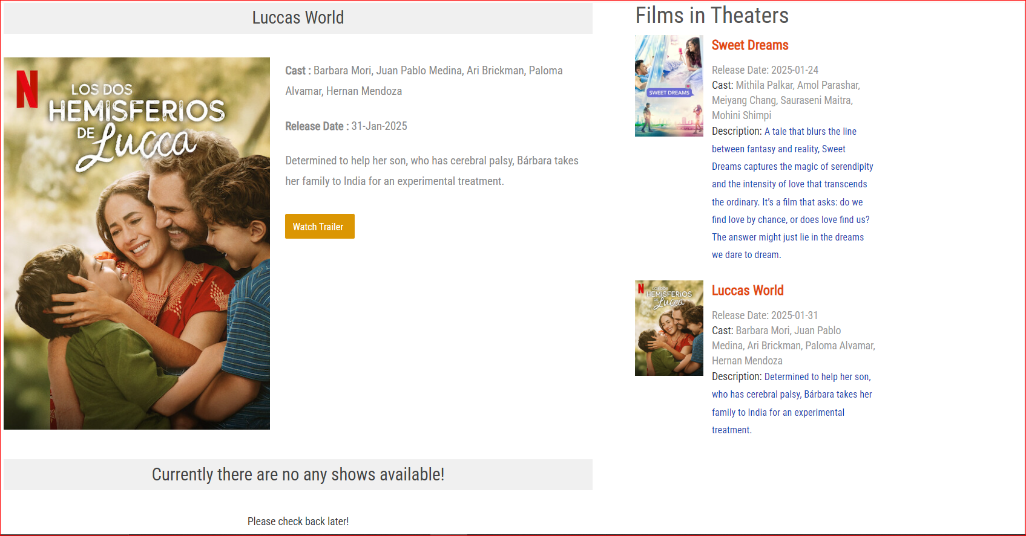
Figure 82 - Shows not Available
If click one movie and then go to that movie id page. Then can check shows are available or not available.

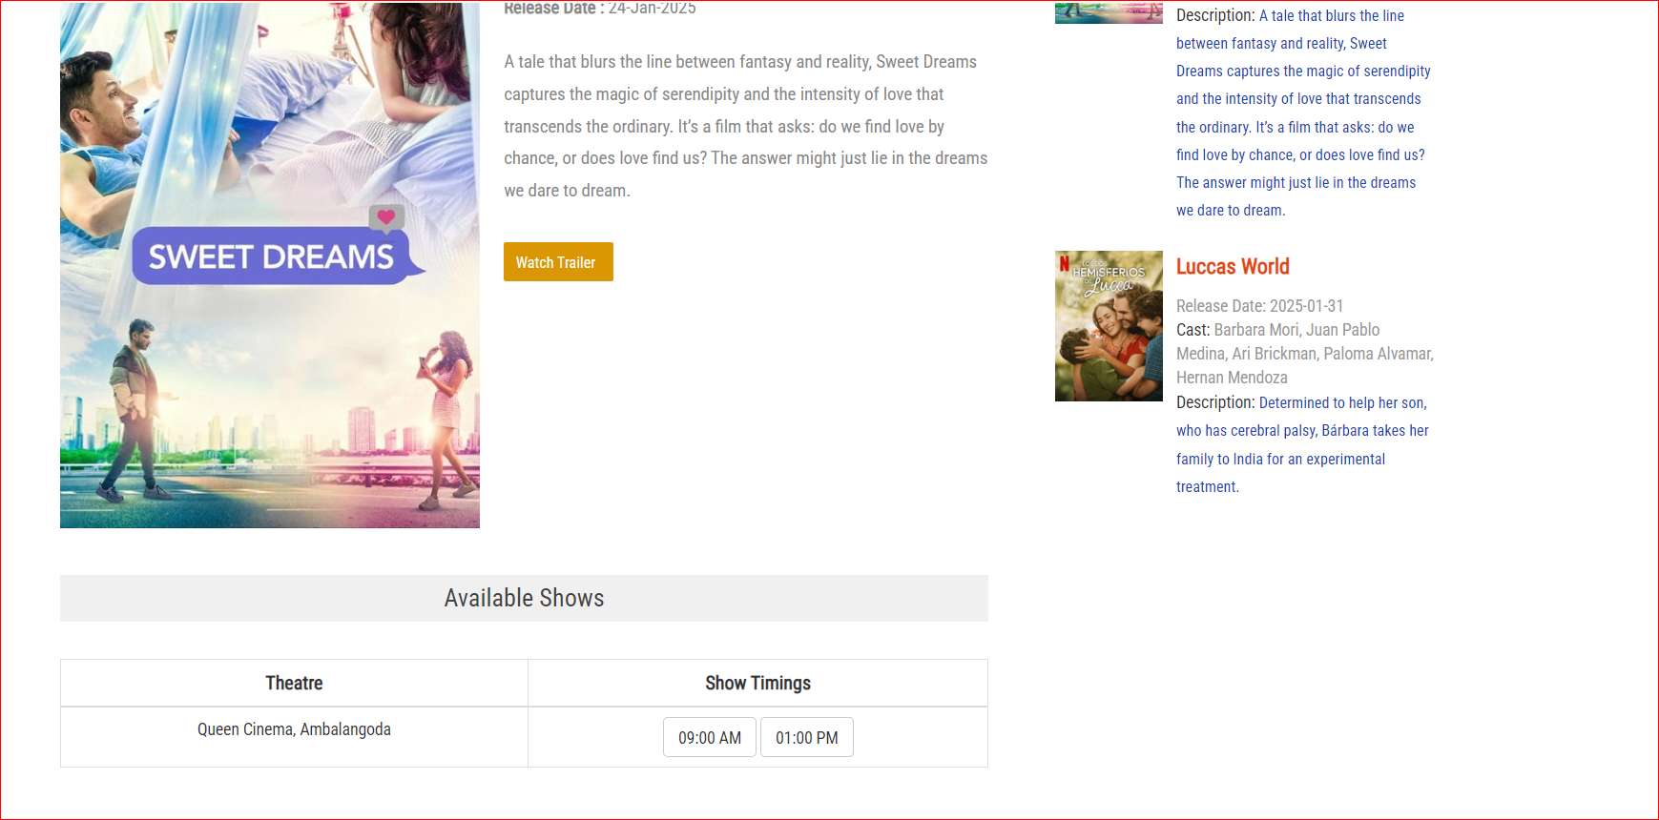
Figure 83 - Shows Available
This Movie has available shows. So customer can check and can booking any number of seats with tickets.
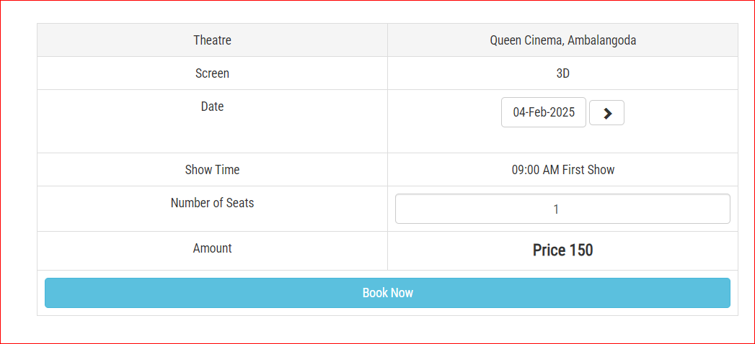
Here has Booking table. So customer can Change any date and any number of tickects.

Figure 84 - Booking Table
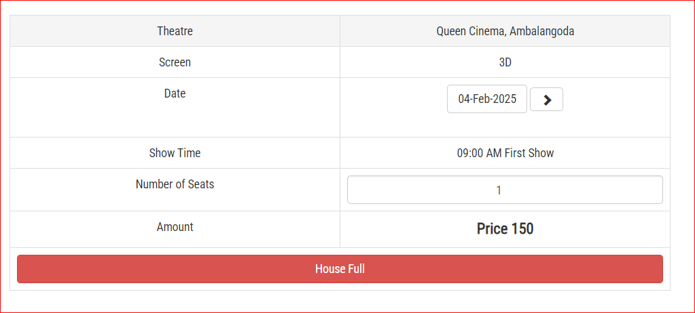
If seats are not available, then customer have to move to another date. This day tickets are not available

Figure 85 - House Full

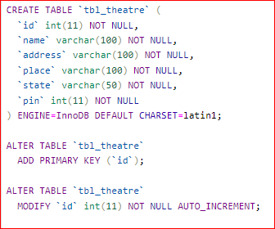
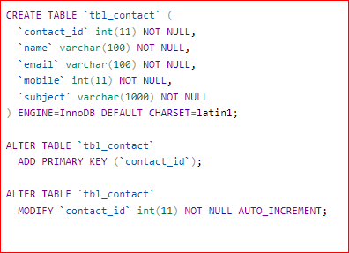
Appendices
Figure 86 - Create Table tbl_theatre
Figure 87 - Create Table tbl_contact

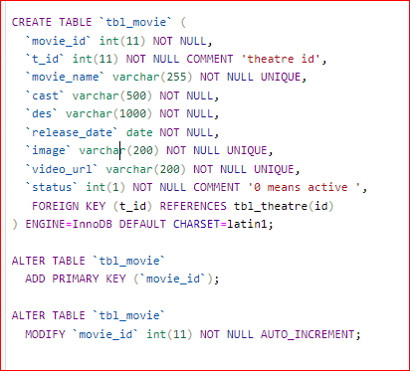
Figure 88 - Create Table tbl_movie
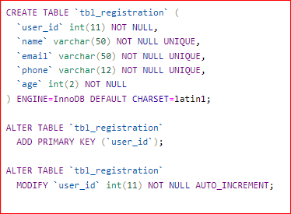
Figure 89 - Create Table tbl_registration

Figure 90 - SQL Create Register Table

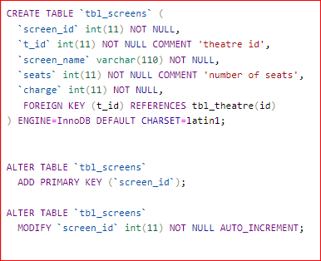
Figure 91 - Create Table tbl_screen

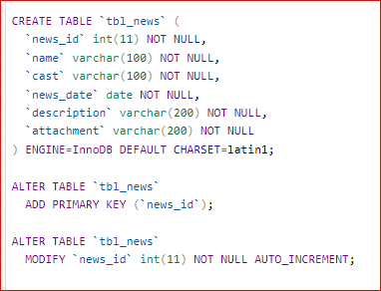
Figure 92 - Create Table tbl_news

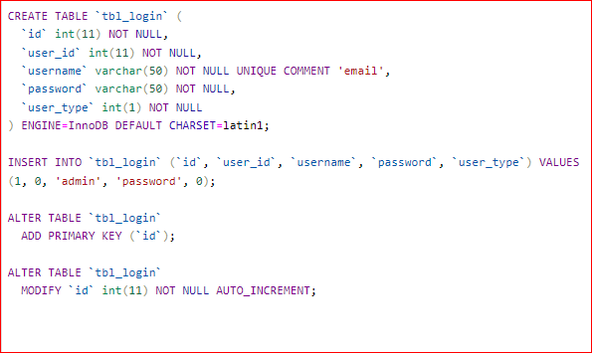
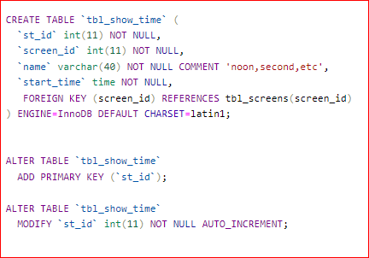
Figure 93 - Create Table tbl_login
Figure 94 - Create Table tbl_showtimes

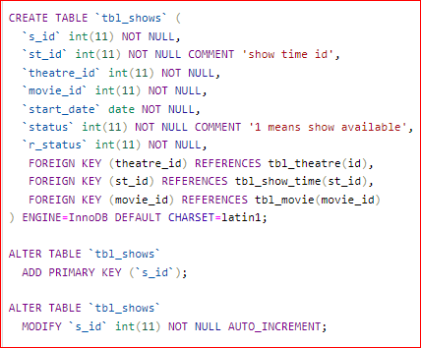
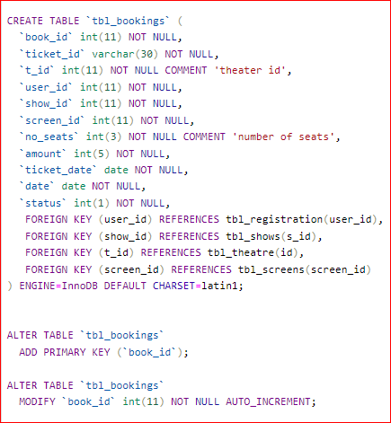
Figure 95 - Create Table tbl_s_id
Figure 96 - Create Table tbl_booking

Conclusion

This database project successfully implements a structured database system for handling movie theater screenings, ticket bookings, and customer interactions. Effective relational databases can be created that efficiently store and retrieve data related to movies, theaters, showtimes, customers, and reservations. Through SQL queries, normalization techniques, and indexing strategies, the system ensures data integrity, consistency, and optimal performance. Features such as seat availability after user authentication and check booking history enhance its overall usability and functionality.
This project demonstrates the practical application of database management principles in a real-world scenario. It provides a foundation for future enhancements such as online booking integration and data analytics for business insights. With proper scalability considerations, this project becomes a comprehensive solution for modern theater management.

References

- Behra, H. (2022). A Final Year Report Project on Online Movie Ticket Booking System. Submitted to the Department of Computer Science & IT, Arka Jain University, Jharkhand. Guided by Prof. Akash Kumar Bhagat.

- Yadav, Aman. 2013. Windows Presentation Foundation Application Development for a Movie Theater. Bachelor’s thesis, Turku University of Applied Sciences. https://www.theseus.fi/bitstream.

- Sony Pro (n.d.). STM-100 Theatre Management System - Sony Pro. Available at: https://pro.sony/en_GL/products/ [Accessed 5 Feb. 2025].

- Studocu (n.d.). Movie Theatre Management System. Available at: https://www.studocu.com/row/ [Accessed 5 Feb. 2025].

